Start your request now by:
- Filling out this form in its entirety, and
- Emailing it to: fssi.bmo@gsa.gov
- One of our BMO Team members will be in contact with you soon.

Last Name:
First Name:
Rank (Please include your Rank if you are a member of the U.S. Armed Forces):
Email Address:
Work Phone:
Cell Phone:
Job Title:
Department or Agency Name (Please put an “X” in front of the correct choice)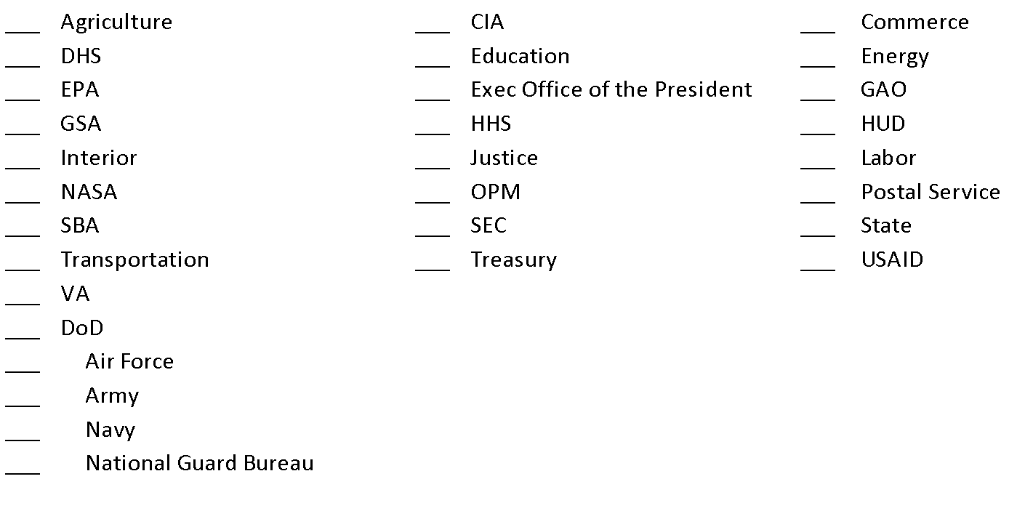
___ Other:
(please write out name)

Sub-Agency Name:
Office or Bureau Name/Region #:
If Military, please provide Base name:
City/State:
Acquisition Role – please select from the options below:
_ By registering for BMO DPA Training, I self-certify to be a duly warranted Federal Contracting Officer (as defined in FAR 2.1 Definitions) in good standing.
_ I am a GS-1102 Contract Specialist working for a duly warranted Federal Contracting Officer.
_ I am a Program/Project Manager
_ Other:
If you are a Warranted Contracting Officer – please select from the options below:
_ The dollar limit on my warrant is above $150,000
_ The dollar limit on my warrant is $150,000 or below
_ N/A
Training Mode – please select a preferred training mode from the list below:
_ In Person
_ Conference Call, or
_ GSA Meeting Space Webinar (Your computer must be ‘Adobe Connect’ compatible and have downloaded the required free software to attend. This may take more than one hour to download and set up.)
Training Class Name:
_ Delegation of Procurement Authority (DPA) – Only warranted Federal Contracting Officers (COs) can receive a DPA; however, open to all Federal Agency personnel.
  - This class is mandatory for COs to complete prior to issuing a task order.

_ BMO Overview Training
To request On-site Group training:
Please let us know the number of people interested in attending if you’d like it on-site (requires a minimum of 25 people) and any other pertinent details in the text box below; we will respond to your request via email. Thank you.
On-site Training (City/State):

- Upon completing this form, email it to: fssi.bmo@gsa.gov
- One of our BMO Team members will be in contact with you soon.
- Also let us know your sense of urgency in your email. Thank you.

