In this Promo/User Guide, we will preview the new enhancements included with the eRETA 10.0 release available to users starting August 1st, 2026

For additional eRETA questions, the following resources are available

●

Visit

www.gsa.gov/ereta

for eRETA training materials

including user guides, video demos and

more.

●

Email us at

eRETA@gsa.gov

for all eRETA questions

Table of Contents
Welcome to eRETA 10.0 ..................................................................................................................................... 2
What You Need to Know ............................................................................................................................. 2
Implementation Timeline ............................................................................................................................ 2
Establishing a G-Invoicing Agreement ................................................................................................................ 3
What is a GT&C? ......................................................................................................................................... 3
Interested in setting up a GT&C before the mandate? ................................................................................. 3
New Features in eRETA ...................................................................................................................................... 4
- Billing Information Tab ........................................................................................................................... 4
- Accounting Details Tab ........................................................................................................................... 6
- Pending Action and OCAS Workflow Updates ........................................................................................ 8
- Financial Review Changes ....................................................................................................................... 9
- Pre-Paid RWA Changes ......................................................................................................................... 10
- Glossary Changes ................................................................................................................................. 11

Welcome to eRETA 10.0
The U.S. Department of the Treasury is implementing G-Invoicing, a government-wide initiative designed to improve the processing of interagency agreements and billing transactions. RETA 10.0 introduces enhancements that prepare the application for this transition while allowing agencies to continue current billing processes during the transition period.

What You Need to Know
No immediate action is required.
- You can continue using current IPAC billing processes for new and existing RWAs during the transition.
- You may begin working with GSA now to establish your General Terms and Conditions (GT&C).
- GSA will contact your agency when it's time to establish G-Invoicing agreements (January 2027).
- After your GT&C is established, list it on your RWA in eRETA while still using IPAC billing.
- Use eRETA to create and manage RWAs throughout the transition and beyond.

Implementation Timeline
GSA will not fully implement G-Invoicing 7600EZ functionality until January 2027 . eRETA’s 7600EZ functionality will be released in two phases:
Phase 1 - Preparation - Create GT&Cs (eRETA 10.0 August 2026)
- Foundational enhancements that prepare eRETA for future G-Invoicing 7600EZ integration.
- We will use the next 6 months to establish RWA GT&Cs with customers, provide training on the upcoming changes, and allow customers to use the GT&C in eRETA.
Phase 2 - Future G-Invoicing Activation (January 25, 2027) ● Full G-Invoicing Bill Type functionality.
- If your agency is ready, new RWAs should use G-Invoicing rather than IPAC billing.

Establishing a G-Invoicing GT&C Agreemen t
What is a GT&C?
A General Terms and Conditions (GT&C) agreement establishes the overall business relationship between GSA and your agency for interagency reimbursable work. The GT&C defines the terms of the agreement and serves as the foundation for future G-Invoicing transactions.
The transition to G-Invoicing requires a GT&C agreement to be in place between trading partners (e.g., your agency and GSA). To get ahead of the mandate, you can proactively set this up now. This will make it faster and easier to fund future RWAs once the 7600EZ G-Invoicing process is implemented.
Interested in setting up a GT&C before the mandate?
Please reach out to ginvoicing.rwa@gsa.gov for more information and assistance.
Please Note: As this is a new government-wide process, GSA is actively working to streamline our internal review and approval steps .

New Features in eRETA

1.) Billing Information Tab
What changed:
- Agency and Office FPDS Codes are now required fields on the Billing Information page for all RWAs.
- Bill Term field is removed from the Billing Information page.
- An optional GT&C Number field and search pop-up for IPAC RWAs is available. This information may be used to support future G-Invoicing processing and reporting requirements.
- Users may save frequently used GT&C Numbers as favorites.
- GT&C selection automatically fills out three new uneditable fields, GT&C Title, Treasury Group Name, and Treasury Group Description.
- Users can no longer manually enter an ALC. ALCwill be automatically populated based on the selected BOAC or GT&C Number.
- eRETA validates to ensure the selected BOAC is valid for the selected GT&C and ALC combination.
Why It Changed:
These enhancements prepare eRETA for the future implementation of G-Invoicing while providing users with additional billing information and reducing manual data entry. The new GT&C fields allow users to begin associating RWAs with future G-Invoicing agreements, while automated field population and updated validations help improve data accuracy.
Note: The G-Invoicing Bill Type is not included in the August 2026 release. Users will continue to use existing IPAC, Non-IPAC, Interfund, and Prepaid billing processes until the future G-Invoicing activation date.
How to Use It:
- Customers: Find and enter your FPDS Codes. The information below is also displayed in the eRETA Glossary if you click one of the blue links available on most fields within eRETA.
  - Funding Agency Code (from FPDS): A 4-character code used in the Federal Procurement Data System (FPDS) to identify the agency providing funding for an award.
○ Funding Office Code (from FPDS): A 6-character code used in the Federal Procurement Data System (FPDS) to identify the office providing the majority of funding for an award. This code is based on the office’s Activity Address Code (AAC).
○ If you don’t know the correct code, contact your agency’s Federal Hierarchy Department Administrator for help.
■ How to find your Department Administrator in SAM.gov:
    - Log in to SAM.gov using your federal credentials.
    - Click Workspace (top right, near “Sign Out”).
    - Scroll down and select User Directory > “See All”.
    - On the left, locate the Role filters.
    - Select Department Administrator only.
    - Review the results and contact someone listed for your agency.
    - If you are unable to locate an appropriate contact, 'Create an Incident' with the Federal Service Desk at fsd.gov for additional support.
○ Validation: The eRETA system will only validate that the codes are the correct length. It will not validate the code itself. Please ensure you enter the correct information, as your GSA point of contact may need to follow up to amend the RWA later if the codes are found to be incorrect.
- Customers: Search for and enter a GT&C Number
  - On the Billing Information page, click the magnifying glass icon to bring up the search screen for GT&C Numbers.
○ Depending on what information you have already entered, some fields within the search may already be populated (Agency ID and ALC).

2.) Accounting Details Tab
What changed:
- The Treasury Symbol field has been moved to the top of the Add/Edit Accounting Detail Line panel.
- An optional field for OMB Object Class Dropdown has been added to the Add/Edit Accounting Detail Line panel.
- GT&C, ALC, and Treasury Group have been added to the TAS Search popup
- Validation to ensure the selected Treasury Symbol(s) are valid for the GT&C, Treasury Group, and ALC has been implemented. Why It Changed:
- These enhancements prepare eRETA for future G-Invoicing implementation while improving Treasury Symbol selection and validation.
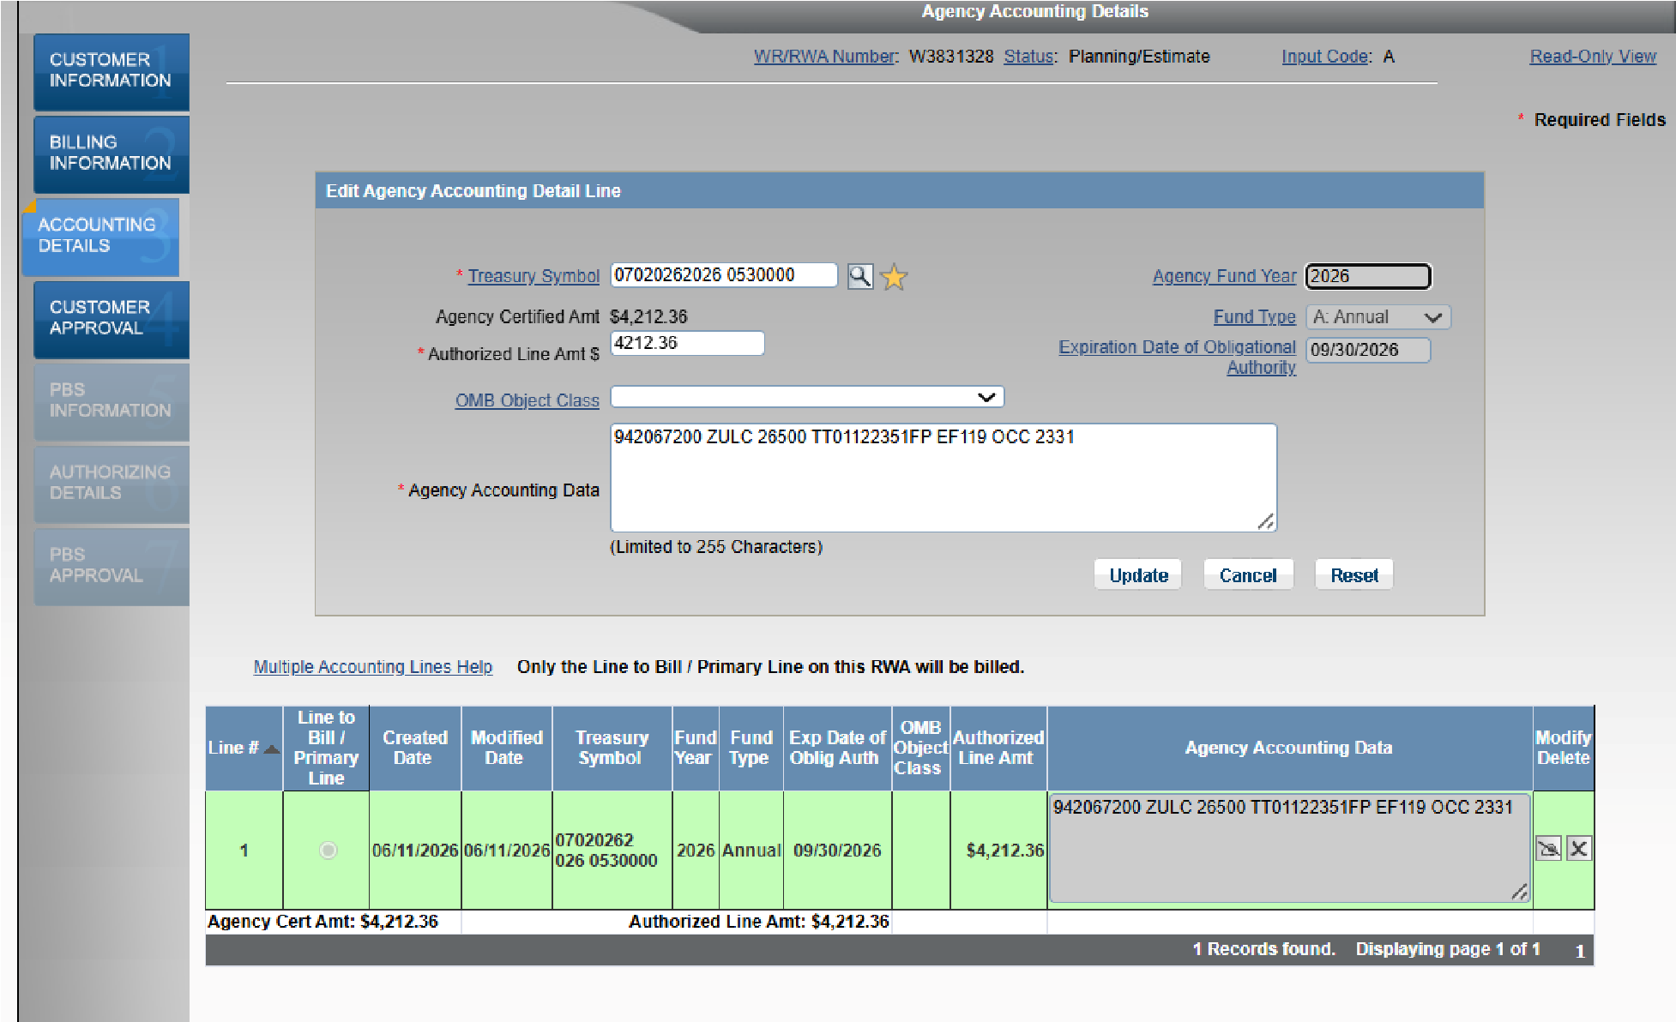
Updated Accounting Detail Line panel with Treasury Symbol and OMB Class fields.
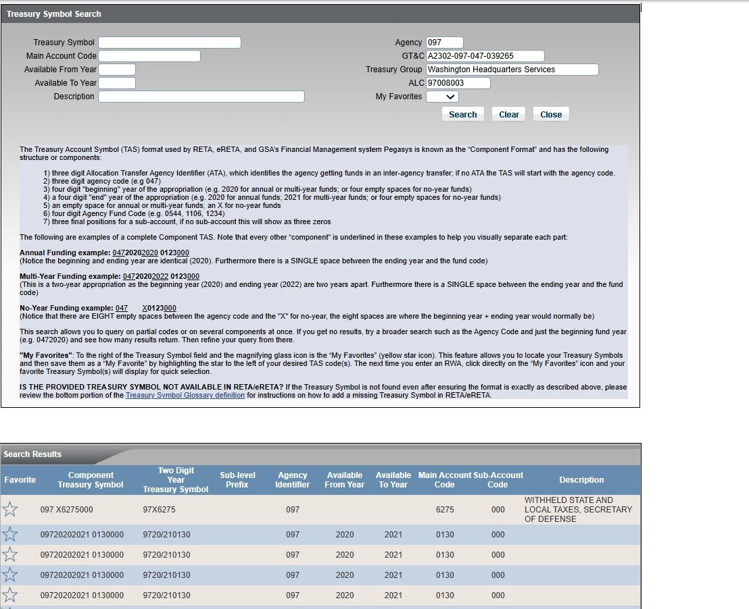
Treasury Symbol Search pop-up with GT&C, Treasury Group, and ALC search criteria

3.) Pending Action and OCAS Workflow Updates
What changed:
- Users can now click “Send to GSA” for OCAS Work Requests and E-Type RWAs even when an Estimate has not been linked or approved
- The Pending Action Logic used by the progress tracker and RWA search filters more accurately identifies records requiring customer or GSA action
Why It Changed:
OCAS agreements could not be sent to GSA until an approved Estimate was linked, creating unnecessary delays in processing. The updated workflow better aligns with OCAS business processes and improves the accuracy of pending action results.

4.) Financial Review Changes
What changed:
- The Financial Review page now displays the RWA Fee associated with each customer funding amount and accounting line.
- Accounting information is now grouped and displayed by line number, allowing users to more easily review funding amounts, direct costs, fees, commitments, obligations, and balances.
Why It Changed:
Prior to this enhancement, OCFO staff manually calculated the fee associated with each customer funding line to ensure direct costs were not overbilled on the accounting line. Displaying this information directly on the Financial Review page reduces manual calculations, improves visibility to fee allocation, and helps eliminate the risk of human error when performing calculations.
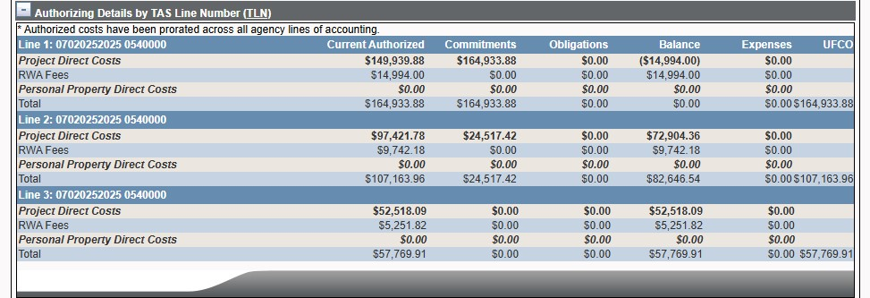
New accounting details by line number section of financial review page

5.) Pre-Paid RWA Changes
What changed:
- C-Type prepaid RWAs can no longer be reduced directly using an X (scope change) or D (cancel) Input Code amendment unless there is a Hold Billing flag applied to the RWA.
- Users attempting to reduce these RWAs will receive a validation message instructing them to process a W- Input Code amendment to set the hold billing flag first.
- When a decrease amendment is processed for eligible C-type RWAs, the RWA will be routed to the Finance Queue so Finance can process any required customer refund.
- T-Input Code amendments to add the termination date will not be allowed when a prepaid (C- and D-Type) RWA has a remaining balance.
Why it changed:
These enhancements ensure that customer refunds are properly reviewed and processed by Finance before prepaid RWAs are reduced. This helps prevent billing issues and improves control over prepaid funding changes.

6.) Glossary Changes
General Terms and Conditions (GT&C):
“Agreement between two federal entities that establishes the required/necessary Inter-Agency Agreement (IAA) governance and accounting data needed by both trading partners.
A GT&C number serves as the master tracking code for an interagency agreement by linking it to specific orders. This is a 20-character code that includes hyphens. The format is typically AYYMM-(Req. AID (3))-(Serv AID (3))-6 digit sequential number.
Work with your G-invoicing contact within your agency to identify the correct GT&C. If you can't find the desired GT&C, please contact us at eRETA@gsa.gov.”
Treasury Group:
“A specific organizational unit within a federal agency that is associated with a GT&C and its related orders.”
OMB Object Class:
“Budget object classification codes are used by the Federal Government to record its financial transactions according to the nature of services provided or received when obligations are first incurred. The Office of Management and Budget (OMB) establishes the major object class codes and titles for use by all Federal agencies.”
Billing Type:
“ Determines how the customer is billed.
Active Billing Types:
G = G-Invoicing, where billings and collections are done through G-Invoicing ( Coming January 2027 )
I = Interfund, customer is internal to GSA, and billings are done through Pegasys.
- = (non-Intra-governmental Payment and Collection (IPAC)): billings are mailed. Customers can remit payment via mail or pay.gov.
- = IPAC: billings and collections take place simultaneously through the Department of Treasury IPAC System.
- = Prepaid: for non-federal customers only (C- and D-type RWAs).”
ALC:
“An eight-character code assigned by the Department of the Treasury, and is used to bill customer agencies via Intra-governmental Payment and Collection (IPAC). The ALC (aka: Treasury Pay-station Designator) is associated with specific Billing Office Address Codes (BOACs). By selecting the appropriate BOAC in RETA, this field will auto-fill. RETA users cannot manually type in an ALC field. Use of the BOAC search pop-up window in RETA, will allow location of a specific ALC.”
Treasury Account Symbol (TAS):
“This field is mandatory for all Federal customers. The data is validated by RETA/eRETA to ensure no billing rejections occur. The Department of Treasury's Shared Accounting Module (SAM) website contains a list of all valid TAS codes for each agency and is updated frequently. Please contact your finance office for further details on how to obtain the necessary information .
The examples below are the ONLY format GSA systems recognize. Using the Treasury Account Symbol (TAS) lookup (magnifying glass icon) is recommended to prevent input errors:
Annual Funding example: 04720202020 0123000
(Notice the beginning and ending year are identical (2020). Furthermore there is a SINGLE space between the ending year and the fund code)
Multi-Year Funding example: 04720202022 0123000
(This is a two-year appropriation as the beginning year (2020) and ending year (2022) are two years apart.
Furthermore there is a SINGLE space between the ending year and the fund code)
No-Year Funding example: 047 X0123000
(Notice that there are EIGHT empty spaces between the agency code and the "X" for no-year, the eight spaces are where the beginning year + ending year would normally be)
Still can't Find a Treasury Symbol in RETA/eRETA?
If the Treasury Symbol is not found on the RETA/eRETA Treasury Symbol lookup, please take the following steps.
- Does the Treasury Symbol exactly match the component TAS format, as indicated in the examples above?
- If it does, confirm if the TAS is valid by looking it up on Treasury's SAM website.
- If the TAS is verified valid on Treasury’s SAM site, it may not be loaded in Pegasys and RETA yet. Send an email to eRETA@gsa.gov with the subject line “Please add the following TAS” and provide the following information:
- the new Treasury Symbol (in the Component TAS format only),
- the Agency Bureau Code of your agency + bureau, and
- a brief description of who the customer is or what the TAS is for (what branch, special project, etc).
The eRETA team will verify the information provided and if valid will have the code added to GSA systems. The new Treasury Symbol will usually be available in RETA/eRETA within 24 hours or less of the eRETA team confirming it will be added.”
Federal Procurement Data System (FPDS) Agency Code:
“A 4-character code used in the Federal Procurement Data System (FPDS) to identify the agency providing funding for an award.”
Federal Procurement Data System (FPDS) Office Code:
“A 6-character code used in the Federal Procurement Data System (FPDS) to identify the office providing the majority of funding for an award. This code is based on the office’s Activity Address Code (AAC).
If you don’t know the correct code, contact your agency’s Federal Hierarchy Department Administrator for help.
How to find your Department Administrator in SAM.gov:
Log in to SAM.gov using your federal credentials.
Click Workspace (top right, near “Sign Out”).
Scroll down and select User Directory > “See All”.
On the left, locate the Role filters.
Select Department Administrator only.
Review the results and contact someone listed for your agency.
If you are unable to locate an appropriate contact, 'Create an Incident' with the Federal Service Desk at fsd.gov for additional support.”
END

