GWAC BPA Toolkit for Ordering Agencies
Table of Contents

GWAC BPA Toolkit 2
SAM/FPDS Reporting 8
GWAC Blanket Purchase Agreement Solicitation Sample 15
Blanket Purchase Agreement Sample 20

GWAC BPA Toolkit for Ordering Agencies
Executive Summary
This toolkit is designed to provide Contracting Officers (COs) and stakeholders with practical guidance for establishing and administering Blanket Purchase Agreements (BPAs) against General Services Administration (GSA) Governmentwide Acquisition Contracts (GWACs). Its purpose is to ensure consistent acquisition practices and alignment with the relevant federal regulations (RFO-2025-16 FAR Subpart 16.5) and the GWAC terms.
Introduction and Purpose
CO’s are authorized to establish single or multiple award BPAs against GSA GWACs to fill repetitive needs for supplies or services. This toolkit is designed to provide stakeholders with practical guidance for leveraging the authority for BPAs under GWACs. The processes and examples in this toolkit:
- Support consistent acquisition practices
- Provide practical sample language when establishing BPAs
- Help ensure your acquisitions align with RFO-2025-16 FAR Subpart 16.5, the GWAC, and the GWAC Ordering Guide
Acquisition Planning Considerations
When establishing a BPA, conduct market research and acquisition planning to the extent necessary to define requirements and support the acquisition strategy.
- A BPA may be preferable to issuing a stand-alone task order if:
  - The requirement is recurring and expected to span multiple years;
  - The scope, labor categories, and skill sets are expected to remain relatively consistent across future orders;
  - Establishing a BPA would reduce acquisition lead time and administrative burden for placing subsequent orders; and/or
  - There are efficiencies or other benefits that may be achieved by combining repeating requirements under a single BPA.
- Define the scope, period of performance, and estimated quantities/dollar value:
  - What is the scope? The OCO establishes the scope of the BPA to ensure the requirements are within scope of the GWAC.
  - What is the appropriate period of performance?
  - What is the total estimated value of the BPA? What is the range of individual order values anticipated under the BPA?
  - How will ordering procedures ensure recipients are provided the fair opportunity procedures in RFO-2025-16 FAR 16.507-3 through 16.507-5?
  - Submit the requirement for an optional GWAC Scope Review.
- A multiple-award BPA may be preferable to a single-award BPA if:
  - More than one GWAC contractor can reasonably perform the anticipated work;
  - Order-level competition is needed to help drive better pricing, performance, or innovative solutions;
  - A slightly longer task order lead time is acceptable in exchange for increased competition and flexibility to meet varying requirements;
  - The requirement includes similar services across multiple geographic areas that may be difficult for a single contractor to fully cover; and/or
  - The requirement includes multiple, diverse task areas that may not be fully addressed by a single contractor.
- On-ramps (to allow additional qualified vendors to join the BPA) may be beneficial if:
  - Additional qualified contractors may be needed over time to maintain competition, provide specialized expertise, or support evolving requirements throughout the BPA ordering period; and/or
  - The BPA is multiple-award and the initial group of BPA holders may not fully address future needs.
  - Contractors must first be awarded a GWAC before being eligible to participate in any BPA on-ramp. Only contractors holding an active GWAC at the time of the BPA on-ramp may be considered for addition to the BPA.
  - Note: if on-ramps are not used and the BPA ordering period exceeds five years, the acquisition team should document that on-ramps are not in the best interest of the Government, consistent with RFO-2025-16 FAR 16.507-2(c)(3)(v).
Acquisition Threshold Considerations
BPAs established under the GWACs follow the same ordering procedures that apply to task or delivery orders under FAR 16.507-3 through 16.507-5 (RFO-2025-16). Accordingly, when establishing a BPA, ordering activities must provide fair opportunity and follow the applicable competition and documentation requirements based on the estimated value of the BPA.
- For planned BPAs exceeding the micro-purchase threshold but not the Simplified Acquisition Threshold (SAT): The contracting officer must fairly consider capable contractors. If sufficient information exists to do so, the BPA may be established without soliciting all contractors.
- Above the SAT but not above $7.5 million: The contracting officer must provide fair notice to all contract holders (e.g., through a solicitation or notice of intent). The notice must allow contractors the opportunity to compete for the BPA.
- Above $7.5 million: The contracting officer must follow the same fair notice process, but with additional transparency. The notice must clearly describe the requirement, allow a reasonable response time, and identify the evaluation factors and their relative importance.
Embrace innovative approaches
Agencies are encouraged to embrace available contracting flexibilities, including the Periodic Table of Acquisition Innovations (PTAI) when establishing and using BPAs to streamline ordering, enhance competition where appropriate, and respond more efficiently to evolving mission requirements. The PTAI is a repository of innovative acquisition techniques and automations you can employ in your BPA acquisition. Examples include:
- Designing more flexible BPA solicitation structures that focus on outcomes and capabilities rather than prescriptive solutions, allowing contractors to propose innovative approaches at both BPA establishment and order level.
- Tailoring evaluation criteria to emphasize technical innovation, scalability, and adaptability for recurring or evolving requirements supported by the BPA.
- Using modular or phased BPAs, where initial BPA awards establish a qualified pool of vendors and competition is refined at the task-order level as requirements mature.
- Incorporating on-ramps into BPAs with shorter ordering periods to maintain competition and allow new qualified contractors to participate over time.
- Aligning BPA ordering procedures with PTIA principles to reduce acquisition lead time, administrative burden, and barriers to entry, particularly for complex or interdisciplinary services.
Establishing the BPA
Issuing a BPA Solicitation
Your solicitation must ensure BPAs are established using the fair opportunity procedures at RFO-2025 FAR 16.507-3 through 16.507-5, based on the total estimated value of the BPA. Your BPA solicitation should also:
- Communicate the scope and objectives of the requirement.
- Adhere to government point of entry posting requirements.
- Allow qualified GWAC contractors to submit proposals for pre-qualified services, labor categories, and pricing.
- Outline the BPA evaluation criteria and ordering placement procedures.
- Establish the ordering period, including any options.
- Identify authorized ordering officials and any limitations on orders.
- Include any additional ordering activity requirements, such as delivery, invoicing, and discounts. GWAC terms and conditions flow down to BPAs and their respective orders.
- Define quality, timeliness, and deliverables in statements of work, performance objectives, or service level agreements (SLAs).
Create the BPA
- Prepare award documentation, including selection rationale. Documentation requirements vary based on estimated BPA dollar value (see FAR 16.507-3 through 16.507-5 (RFO-2025-16) for details).
- At a minimum, include the elements identified at RFO-2025-16 FAR 16.507-2(c)(3))
- Establish ordering procedures that ensure BPA recipients receive fair opportunity, per RFO-2025-16 FAR 16.507-3 through 16.507-5, based on total estimated order value, unless an exception applies.
- BPAs should state the estimated value, but should not specify a ceiling.
- Include additional terms and conditions, as needed.
- Confirm that the period of performance for the underlying GWAC, including all option periods, is sufficient to cover the entire BPA ordering period. The BPA ordering period must not extend beyond the remaining term of the GWAC.
Illustration:
- If a GWAC expires on December 5, 2034, the BPA ordering period cannot extend beyond that date.
- If a BPA is established in FY 2026, a 5-year ordering period is permissible because it falls within the remaining GWAC term.
- If a BPA is established in FY 2032, when only 2 years remain, a 5-year ordering period is not permitted. The BPA must end no later than December 5, 2034.
- When establishing BPAs with 8(a) participants, the contracting office must submit an offering letter for, and SBA must accept, the BPA in accordance with RFO-2025-19 FAR 19.108-6. SBA acceptance of the GWAC does not automatically cover the BPA or orders issued under it.
*Note: When establishing a sole source single-award BPA, a Justification for an Exception to Fair Opportunity is required with a public notice on a Government Point of Entry (GPE), such as SAM.gov (see FAR 16.505 (b)(2), Exception to the Fair Opportunity Process).
BPA Administration and Ordering
Placing BPA Orders
- All authorized BPA ordering Contracting Officers must have a GWAC delegation of procurement authority (DPA).
- Follow the ordering procedures of the BPA.
- Orders must be within the scope of both the BPA and the GWAC contract.
- Try to keep submission requirements to a minimum and use streamlined procedures when practical.
- Document the file to the extent necessary to support the award decision.
- BPAs (including orders/calls issued under a BPA) must be solicited and awarded prior to the expiration of GWAC and may extend up to five years and six months (which includes the extension at FAR 52.217-8, Option to Extend Services).
BPA Administration
When administering a BPA, it is recommended that you:
- Provide BPA terms to all authorized ordering officials
- Review BPAs on an annual basis or prior to exercise of option to:
  - Ensure the BPA still represents the best value
  - Verify the BPA holder’s GWAC remains in effect
  - Review BPA usage, contractor performance, and compliance with BPA terms
  - Ensure that the BPA ordering procedures are being followed
  - Consider if additional price discounts or other concessions can be obtained
  - Consider if conditions warrant the on-ramping of new suppliers or modification of existing agreements
BPA Reference Materials
The following examples are a suggested best practice, but not mandatory for placing BPAs under GWAC.
- Sample GWAC BPA Solicitation – page 15
- Sample GWAC BPA – page 20
FAR Companion (see FC 16.507-2(c)(3), BPAs under multiple award contracts)

SAM/FPDS Reporting
BACKGROUND
- To ensure consistent data/reporting, GSA is issuing these instructions for a reporting workaround until future SAM/FPDS system configurations are made.
- The Revolutionary FAR Overhaul (RFO) allows for placing BPAs against a FAR Part 16 indefinite-delivery/indefinite-quantity vehicle (IDV). Both government-wide reporting systems and FAS’s own systems need to be configured to allow such contracts to be reported, as previous policy only allowed BPAs to be placed against MAS contracts (and the systems reflect that.)
- RFO FAR 4.301(a)(1) requires agencies to report to FPDS the IDV and “calls and orders awarded under it”, but does not specifically require reporting of BPAs. Agencies may submit other contract actions if approved in writing by OFPP.
PROPOSED GUIDANCE
For OCOs:
- When awarding a BPA against a GSA non-MAS contract (GWAC), in FPDS report the BPA award number in Contract ID (PIID) and the non-MAS master contract number in Referenced IDV (PIID). Report Total Obligation and Total Contract Value as $0. Include the BPA estimated value in the Description field.
- When awarding orders off of a BPA awarded against a GSA non-MAS contract, in FPDS report the order/call award number in Contract ID (PIID) and the non-MAS master contract number in Referenced IDV (PIID). In the order Description field, please include the BPA award number.
For Industry Partners:
- When reporting the award of a BPA against your GSA non-MAS contract (GWAC), report the BPA contract number as the Order Number and the Contract Number as your non-MAS master contract. Report Total Obligation and Total Contract Value as $0. In the Order Description field, include “BPA” as well as the estimated value.
- When reporting the order off of a BPA awarded against your GSA non-MAS contract (GWAC), report the order number as the Order Number and your non-MAS master contract as the Contract Number. In the Order Description field, include “Awarded against BPA” and the BPA contract number.
See annotated FPDS screenshot examples highlighting key tracking fields.
Multiple Award BPA - FPDS Reporting Example:
BPA awarded to two contractors, Contractor A and Contractor B
The steps below cover the main points this office recommends for tracking purposes, but they do not include all the required fields needed to complete the FPDS submittal.
Step 1 Record the BPA Established Agreement Number for Contractor A
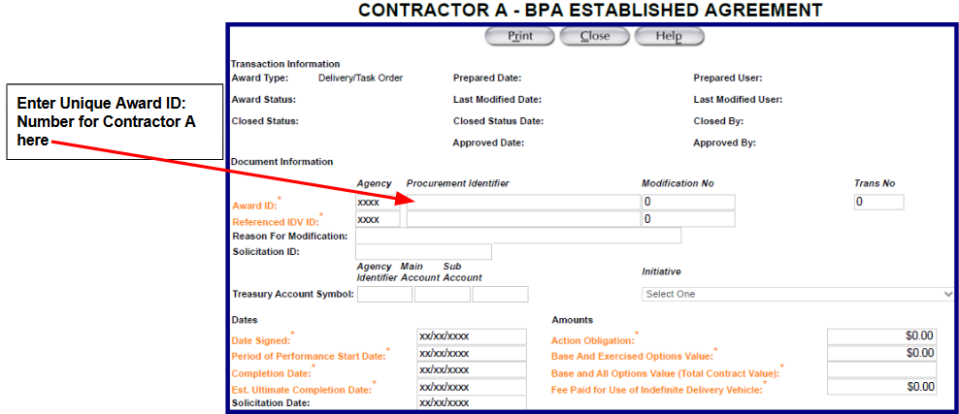
Step 2 Record the Referenced IDV ID: Number for the GWAC for Contractor A (*This is unique to Contractor A)
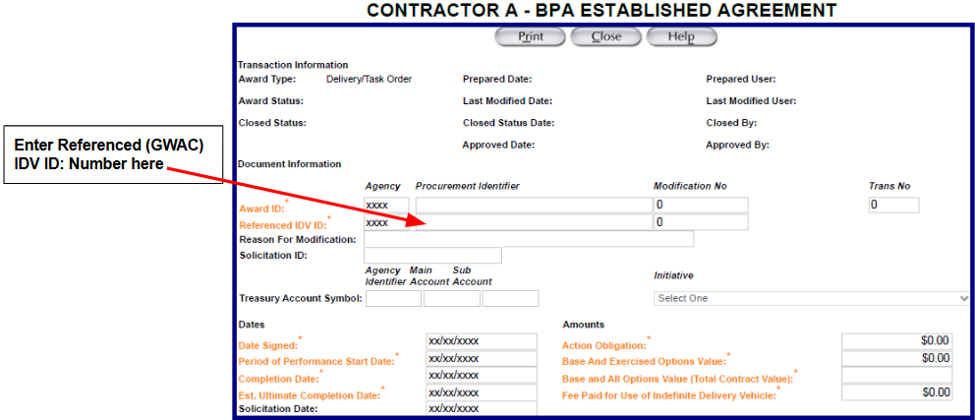
Step 3 Record the Solicitation ID: Number for the BPA Established Agreement (* Solicitation ID
Number will be the same for both Contractor A and B)
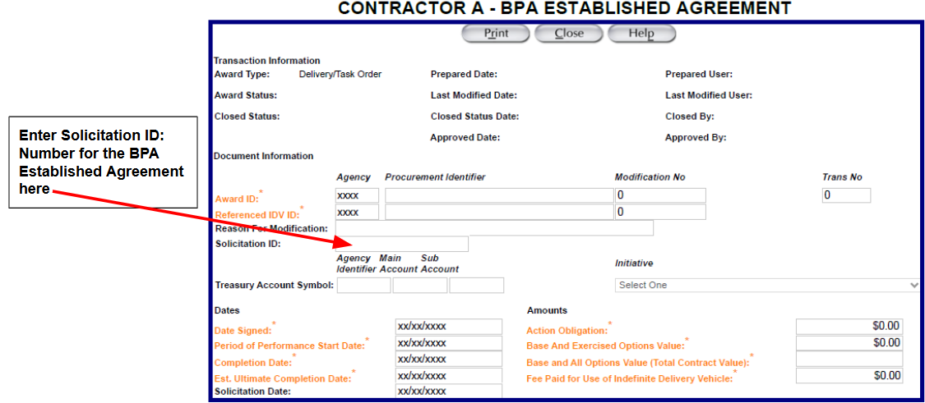
Step 4 Record the Estimated Value of the BPA Established Agreement (* Estimated Value will be the same for both Contractor A and B)
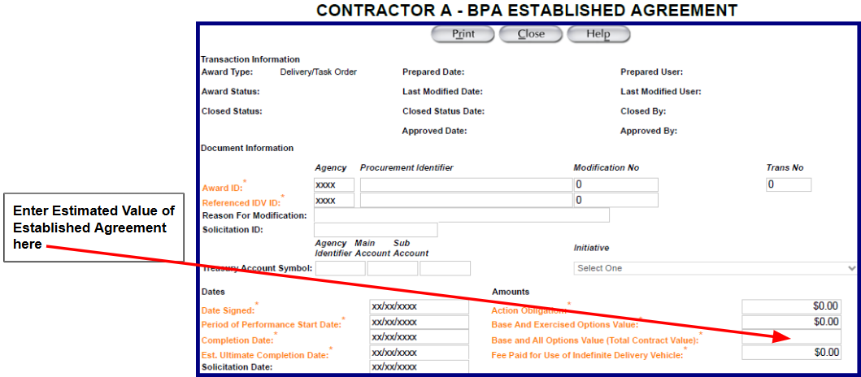
Step 5 Include a description for the BPA Established Agreement, Contractor A’s BPA Award Number, Total Period of Performance (Base + Option Periods), and Total Estimated Value
You will repeat the same steps above for Contractor B
Step 1 Record the BPA Established Agreement Number for Contractor B
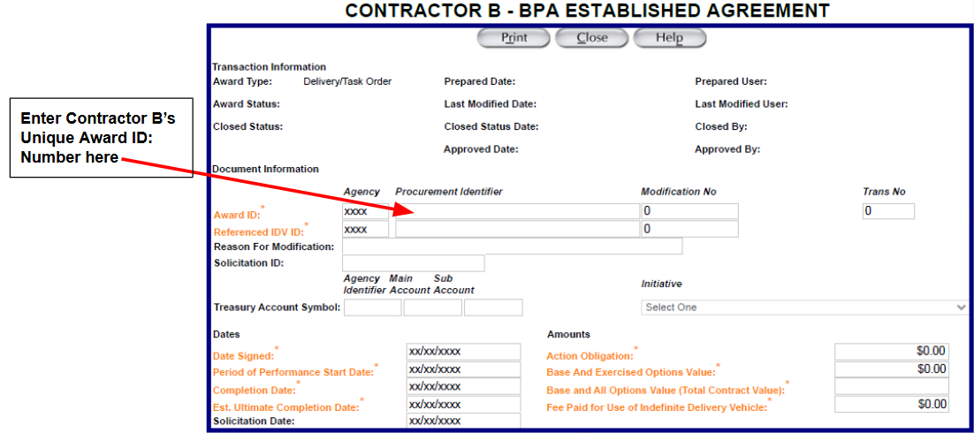

Step 2 Record the Referenced IDV ID: Number for the GWAC for Contractor B (*This is unique to Contractor B)
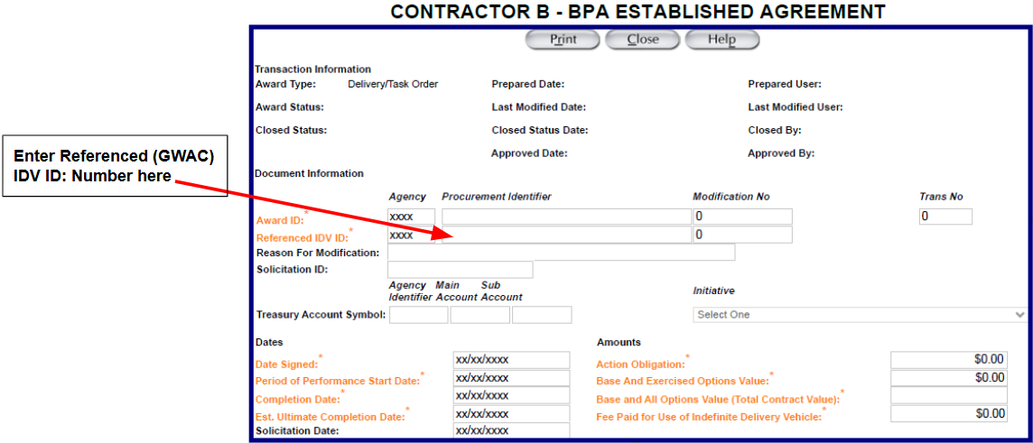

Step 3 Record the Solicitation ID: Number for the BPA Established Agreement (* Solicitation ID Number will be the same for both Contractor B and A)
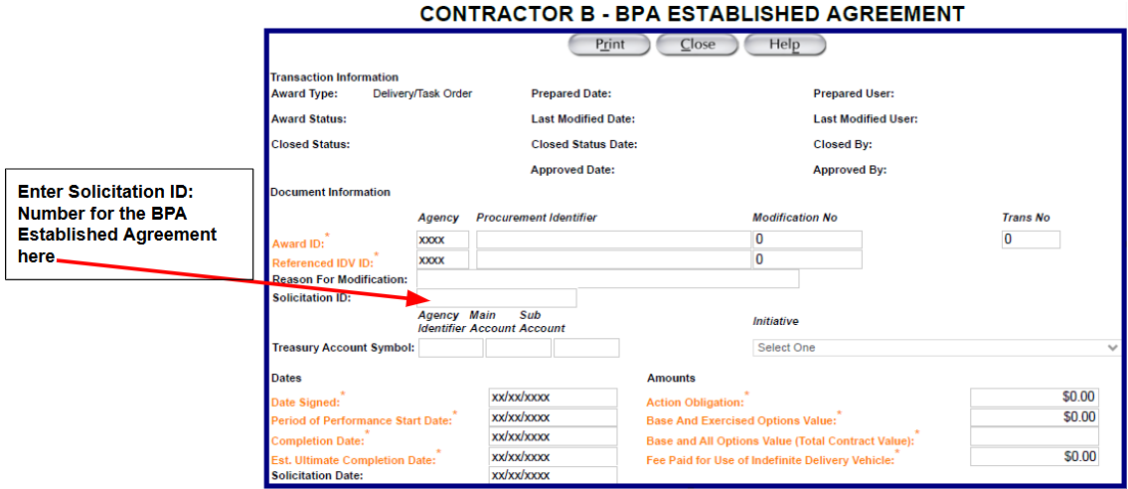
Step 4 Record the Estimated Value of the BPA Established Agreement (* Estimated Value will be the same for both Contractor B and A)
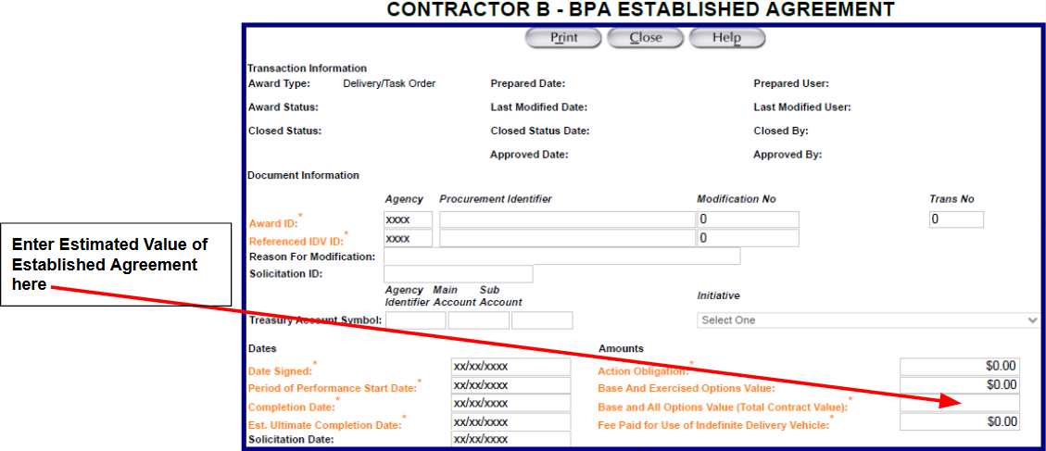
Step 5 Include a description for the BPA Established Agreement, Contractor B’s BPA Award Number, Total Period of Performance (Base + Option Periods), and Total Estimated Value
Contractor A BPA Order/Call from Multiple Award above
- FPDS Reporting Example:
The steps below cover the main points this office recommends for tracking purposes, but they do not include all the required fields needed to complete the FPDS submittal.
Step 1 Record the BPA order/call to Contractor A in the Award ID: Field in FPDS
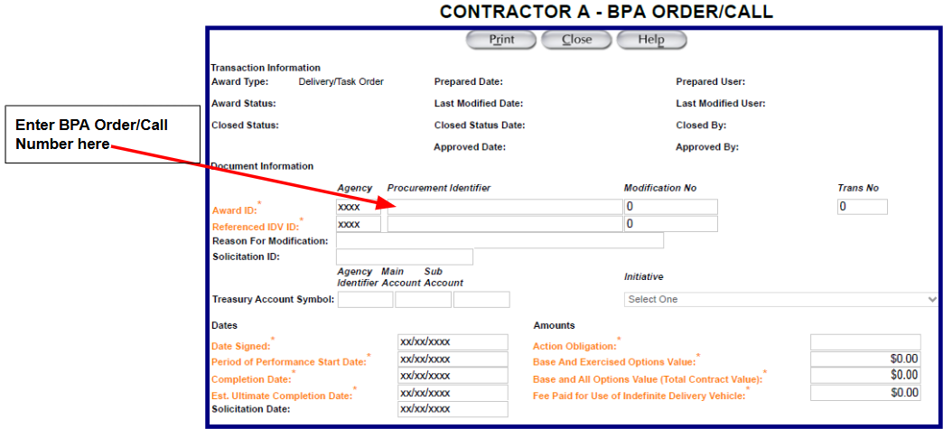
Step 2 Enter Contractor A’s GWAC number in the Referenced IDV ID: Field in FPDS
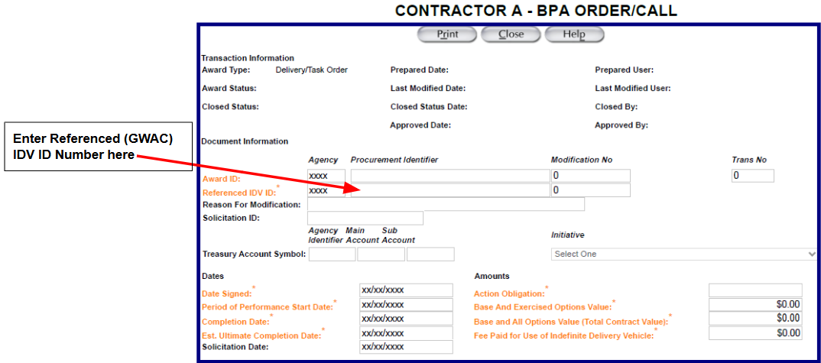

Step 3 Enter the BPA Order/Call Solicitation number in the Solicitation ID: Field in FPDS
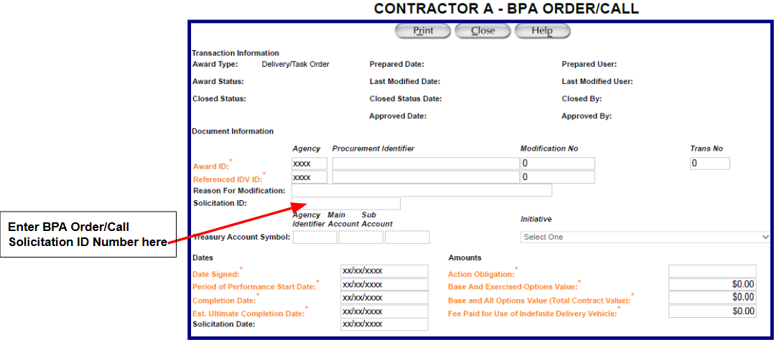
Step 4 Enter the BPA Order/Call Award Obligation Amount in the Action Obligation field in FPDS
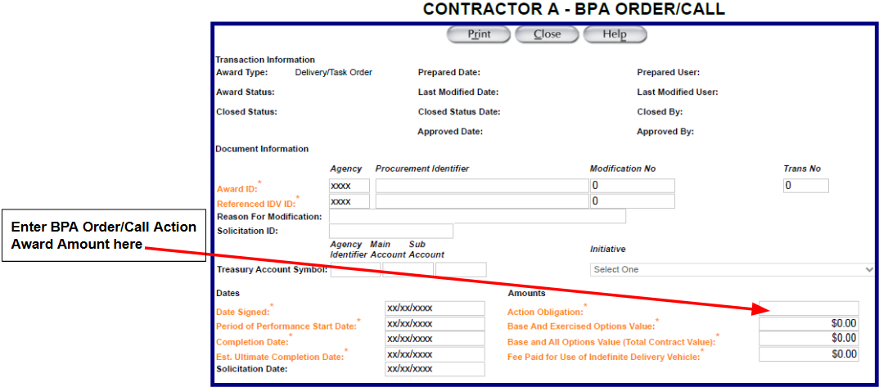
Step 5 Include additional information in the Description Field

SAMPLE OF A GWAC BLANKET PURCHASE AGREEMENT (BPA) SOLICITATION

GWAC
Agency/Office: [Insert Agency/Office Name]
Solicitation Number: [Insert Solicitation Number]
GWAC Parent Contract Type:
☐ Alliant 2
☐ Alliant 3
☐ VETS 2
☐ Polaris (specify pool)
☐ STARS III
GWAC Pool(s) (if applicable): [e.g., HUBZone, Women-Owned Small Business (WOSB)]
BPA Type: ☐ Single-Award ☐ Multiple-Award
Estimated BPA Ceiling: $[XXX,XXX,XXX] (Not a Guarantee)
BPA Ordering Period: [e.g., Five (5) years from BPA award date, Three (3) years from BPA award date; may not exceed GWAC ordering period]
Instruction: Delete all instructional notes prior to release. Tailor all bracketed text to the requirement.

1.0 OVERVIEW
1.1 Purpose
The purpose of this solicitation is to establish [insert number] Blanket Purchase Agreement(s) (BPA(s)) against the GWAC [insert contract type] contract for the services described herein and in the attached documents.
Services are anticipated to begin on or about [insert date]. The BPA ordering period will be [insert period], subject to the limitations of the GWAC contract.
1.2 GWAC Eligibility
To be eligible for BPA award, offerors must hold an active GWAC contract under the following pool(s)/domain(s):
- [Insert applicable pool(s)/domain(s)]
Responses received from contractors that do not meet this requirement at the time of submission will be ineligible for award.
1.3 Commitment of Funds
This BPA does not obligate funds. Funds will be obligated only through individual task orders issued under the BPA.
1.4 Questions
Questions regarding this solicitation must be submitted no later than [insert date and time] via:
☐ GSA eBuy
☐ Email to [insert email address] with subject line: “BPA Solicitation – [Solicitation Number]”
The Government is not obligated to respond to questions received after this deadline.
1.5 Proposal Submission Instructions
This solicitation is following the fair opportunity procedures provided in FAR 16.507-3 through 16.507-5 ([insert Agency name] Class Deviation RFO-2025-16) based on the estimated value being [insert total estimated value].
Proposals must be submitted via one of the following methods:
☐ Email Submission: Proposals shall be submitted to [insert email address] no later than [insert date and time].
☐ GSA eBuy Submission: Proposals shall be submitted via GSA eBuy no later than [insert date and time].
Proprietary information must be clearly marked and will be protected in accordance with applicable law. Unmarked information may be subject to release under FOIA.
1.6 BPA Ordering Procedures
- BPA orders may be issued as Firm-Fixed-Price (FFP), Time-and-Materials (T&M), Labor-Hour (LH), or Cost Reimbursement contract type, and specified in each BPA order solicitation. Note: Ordering activities must confirm allowable contract types under the governing GWAC Master Contract (IDIQ) prior to issuance.
- Orders may be issued at any time during the BPA ordering period.
- Order performance periods will be specified at the task order level and may include options, as authorized.
- Orders will be awarded and administered by the order-level Contracting Officer, consistent with this BPA and fair opportunity requirements in RFO-2025-16 FAR 16.507-2(c)(3)(iv)(B).
- Only the BPA Contracting Officer may modify the BPA.
*Note: When establishing a sole source single-award BPA, a Justification for an Exception to Fair Opportunity is required with a public notice on a Government Point of Entry (GPE), such as SAM.gov (see FAR 16.505 (b)(2), Exception to the Fair Opportunity Process).
2.0 Authorized Ordering Activities
Orders may be placed by:
- [Agency / Bureau / Office]
All Ordering Contracting Officers must have a GWAC delegation of procurement authority (DPA).
3.0 GENERAL INSTRUCTIONS TO OFFERORS
3.1 General Submission Requirements
At a minimum, proposals must include:
- Solicitation number
- GWAC contract number
- Offeror point of contact (name and email)
Any exceptions to solicitation terms must be clearly identified in the proposal. Submission of a proposal without identified exceptions constitutes acceptance of the solicitation terms.
Proposals must remain valid for [insert number] calendar days.
3.2 Proposal Organization
Offerors shall submit two (2) separate volumes:
Volume 1 – Technical Proposal
- Organized in accordance with the evaluation factors
- Page limit: [insert page limit], excluding resumes (if applicable)
Volume 2 – Price/Cost Proposal
- Completed pricing spreadsheet (Attachment 1)
- Pricing must align with the labor categories in the government requirements (Attachment 2)
3.3 Pricing Instructions
Include the applicable paragraph(s) below based on BPA order type:
FFP Orders
The offeror shall submit firm-fixed prices for all line items for each performance period. Prices shall be inclusive of all costs necessary to perform the work.
T&M/LH Orders
The offeror shall submit fully burdened labor rates for each labor category. Ceiling prices and estimated quantities are provided for evaluation purposes. The Government will not be liable for costs exceeding the established ceiling.
Cost-Type Orders
The offeror shall submit estimated, fully burdened cost rates by labor category. Costs will be evaluated for reasonableness and realism. The Government is not obligated to reimburse costs exceeding the approved estimated cost ceiling.
4.0 EVALUATION FACTORS
The Government will make a best-value determination considering the factors below.
Non-Price Factors
- [Insert factors and relative importance]

Price/Cost
Include the applicable evaluation paragraph based on order type (FFP, T&M/LH, or Cost-Type).
The Government reserves the right to conduct clarifications and to award without discussions.
5.0 PROVISIONS
The terms and conditions of the awardee’s GWAC contract apply to the BPA and all orders issued thereunder. Additional provisions applicable to this BPA and resulting orders are identified below:
[Indicate any FAR or FAR supplement provisions needing completion by the offeror. Note: This template assumes a separate document for clauses and additional terms and conditions (Attachment 3)]
6.0 ATTACHMENTS
The attachments below are incorporated into the resulting BPA. [Should be tailored to include any Agency-specific clauses.]
- Attachment 1: Pricing Spreadsheet
- Attachment 2: Government Requirements (Performance Work Statement (PWS)/Statement of Work (SOW)/Statement of Objectives (SOO))
- Attachment 3: Clauses, Terms, and Conditions

SAMPLE OF A GWAC BLANKET PURCHASE AGREEMENT (BPA)

DISCLAIMER: This is an example/illustrative purpose and the information contained herein is not binding.
BPA IDENTIFICATION
BPA Number: [To be assigned]
Parent Contract: GWAC Contract No. [XXXX]
GWAC Pool (if applicable): [e.g., HUBZone, Women-Owned Small Business (WOSB)]
BPA Type: Multiple-Award BPA
Estimated Value: $[XXX,XXX,XXX] (Not a guarantee)
Ordering Period: [e.g., Five (5) years from BPA award]
No funds are obligated at the BPA level.
PURPOSE
This BPA is established to provide integrated, complex professional services in support of mission requirements that:
- [Insert scope here]
This BPA streamlines future task-order competitions while preserving fair opportunity among BPA holders.
RELATIONSHIP TO GWAC CONTRACT
This BPA is an agreement that should comply with the terms and conditions of the GWAC contract. It is established under the authority of the GWAC contract and FAR Part 16 ([Insert Agency Name] Class Deviation RFO-2025-16) ordering procedures.
All terms and conditions of the parent GWAC contract apply.
SCOPE OF BPA
General Scope
PURPOSE
This BPA is established to provide integrated, complex professional services in support of mission requirements that:
- [Insert scope here]
This BPA streamlines future task-order competitions while preserving fair opportunity among BPA holders.
[Services may require interdisciplinary teams, advanced certifications, and subject-matter expertise across multiple GWAC domains.]
Out-of-Scope
Supplies or services outside the scope of the parent GWAC contract are not authorized under this BPA.
BPA HOLDERS
The following GWAC contractors are BPA holders:
Contractor | GWAC Contract No.
[Contractor A] | [XXXX]
[Contractor B] | [XXXX]
[Contractor C] | [XXXX]

ORDERING PROCEDURES (FAIR OPPORTUNITY)
Order Competition
All task orders issued under this multiple-award BPA shall provide BPA holders a fair opportunity to be considered, consistent with the overhauled FAR Part 16 and the parent GWAC contract.
Order-Level Evaluation
Orders may be awarded using:
- Tradeoff, or
- Lowest Price Technically Acceptable (when appropriate)
Evaluation factors may include:
- Technical approach
- Management and staffing plan
- Specialized experience
- Past performance
- Price or cost
INCORPORATED INTO BPA
Attachment 1 Pricing Spreadsheet
Attachment 2 [Insert Requirements document (Performance Work Statement (PWS)/Statement of Work (SOW)/Statement of Objectives (SOO))]
Attachment 3 Clauses, Terms and Conditions Applicable to Resultant BPA
ORDER TYPES
Orders under this BPA may be issued as [Firm-Fixed-Price (FFP)/Time-and-Materials (T&M)/Cost-Reimbursement], as an authorized contract type under the IDIQ.
AUTHORIZED ORDERING ACTIVITIES
- Orders may be placed by:
  - [Agency / Bureau / Office]
  - All Contracting Officers will be delegated GWAC ordering authority.
BPA ADMINISTRATION
Contracting Officer Responsibilities
The BPA Contracting Officer is responsible for:
- BPA administration and oversight
- Ensuring fair opportunity compliance
- Monitoring BPA ceiling and performance
- Modifying or canceling the BPA as needed

MODIFICATION AND CANCELLATION
The Contracting Officer may modify or cancel the BPA at any time if it is determined to be in the Government’s best interest. Cancellation does not affect active task orders.

