Update - IRS Employee’s Withholding Allowance Certificate (IRS Form W-4) for Calendar Year 2020

The GSA payroll system and Employee Express (EEX) have been updated to process the revised IRS Form W-4. These changes will also be reflected on every employee’s Leave and Earnings Statement (LES) and will display either the employee “Exmpts” or the “Multi Jobs” (which is new for the 2020 W-4).

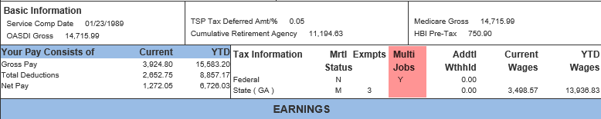

GSA and payroll client employees already onboard with withholdings do not need to do anything at this time, but if they would like to update their Federal withholding elections, they can update them in EEX.

All new onboarding employees (effective start date April 26, 2020, and after) will need to complete and send a completed 2020 IRS Form W-4 through their servicing HR office to be processed by the GSA Payroll Services with their first paycheck. Employees with access to EEX (“Welcome to Employee Express - Employee Express” employeeexpress.gov) can access and adjust their tax withholdings to be effective in the next pay period ending.

The IRS provides “FAQs on the 2020 Form W-4” that includes instructions on form completion. The website for this information can be found at https://www.irs.gov/newsroom/faqs-on-the-2020-form-w-4.

The IRS and GSA Payroll Services strongly urge all employees to periodically review and as necessary adjust their tax withholdings to avoid having too little or too much withheld from your paychecks. To perform a quick “paycheck checkup” use the IRS withholding calculator https://www.irs.gov/individuals/tax-withholding-estimator).

Please contact the GSA Payroll Operations Customer Service Team ​(844)-303-6515 or KC-Payroll.Finance@gsa.gov for further assistance or questions.

