- Question: Do we need to compete BPA orders?

Answer: If there is more than one contractor on the BPA, yes, orders must be competed in accordance with the BPA ordering procedures the fair opportunity procedures in RFO-2025-16 FAR 16.507-3 through 16.507-5, based on the total estimated value of the order (see RFO-2025-16 FAR 16.507-2(c)(3)(iv)(B)) (unless an exception applies).

- How can we best make the business case for OASIS+, given that—unlike GSA MAS, which allows a single BPA with both unrestricted and set-aside orders—it requires at least two separate BPAs (Unrestricted and Small Business), increasing administrative burden?

Answer: It is possible to combine multiple requirements under a single solicitation through a Fusion Procurement. This technique allows an acquisition team to combine multiple requirements spanning different OASIS+ NAICS into a single solicitation that would otherwise be issued separately (see the Periodic Table of Acquisition Innovations (PTAI) for more information). Fusion Procurements streamline the review process by submitting one solicitation package for review (i.e to legal, higher level leadership, etc.) rather than multiple solicitation packages. Even though the requirements are combined into one solicitation, each requirement can still be evaluated separately and result in separate awards. This concept could be applied across domains or socioeconomic contracts. Each awarded BPA would have to be specific to each OASIS+ domain and/or socioeconomic contract.

While GSA MAS allows a single BPA to support both unrestricted and small business set-aside orders under multiple SINs, OASIS+ uses a separate contract structure for Unrestricted (UR) and Small Business (SB). As a result, achieving the same flexibility requires establishing separate BPAs under each contract.

However, the separate contract structure provides several advantages:
- Clear and compliant competition pools.
- Each BPA is aligned to a defined contract (UR or SB), ensuring that all holders are eligible at the contract level, which reduces protest risk and simplifies set-aside determinations.
- Streamlined ordering decisions.
- OCOs do not need to reassess eligibility at the BPA level—socioeconomic qualifications are already established and reported correctly in SAM/FPDS, making ordering more efficient and defensible.
- Targeted acquisition strategies
- Separate BPAs allow agencies to intentionally set-aside requirements (e.g., SB-focused work vs. unrestricted requirements), improving alignment with small business goals.
- Reduced ambiguity in evaluation and reporting
- Distinct BPAs eliminate confusion regarding vendor eligibility and how awards are reported, particularly for socioeconomic credit.

- MAS allows a BPA to utilize multiple SINs. Under OASIS+, the OCO must select a single CLIN for the BPA, but could the BPA’s scope cover multiple NAICS codes?

Answer: It is possible to combine multiple requirements under a single solicitation through a Fusion Procurement. This technique allows an acquisition team to combine multiple requirements spanning different OASIS+ NAICS into a single solicitation that would otherwise be issued separately (see the Periodic Table of Acquisition Innovations (PTAI) for more information). Fusion Procurements streamline the review process by submitting one solicitation package for review (i.e to legal, higher level leadership, etc.) rather than multiple solicitation packages. Even though the requirements are combined into one solicitation, each requirement can still be evaluated separately and result in separate awards. This concept could be applied across domains or socioeconomic contracts. Each awarded BPA would have to be specific to each OASIS+ domain and/or socioeconomic contract.However, this does not limit the overall scope of the BPA to narrowly defined requirements.

OASIS+ is designed to support integrated, multidisciplinary services, and a BPA may include requirements that span multiple functional areas, provided the work remains predominantly within the scope of the awarded domain and its assigned NAICS code.

If significant portions of a requirement span multiple domains or NAICS codes, the OCO should consider:

- Establishing separate BPAs under different domains and NAICS codes, or
- Structuring the requirement so that the primary purpose aligns with one, predominant domain/NAICS code, with ancillary support included as part of the total solution.

- Should the OASIS+ PMO allow OCOs the same flexibility as MAS—where BPAs are solicited through eBuy, but Call Orders can be solicited and managed through alternate methods?

Answer: While OASIS+ BPAs must be established using GSA eBuy to provide fair notice to all eligible contract holders, OCOs are not required to use eBuy for all subsequent BPA call orders.
Consistent with FAR 16.507-2, Fair Opportunity Procedures (RFO-2025-16), OCOs may use alternative methods to solicit and manage BPA call orders (e.g., email, agency-specific procurement systems, or other electronic means), provided that:
- Fair opportunity is provided to all BPA holders, unless an exception applies;
- The method ensures transparency, competition, and proper documentation of the award decision; and
- The approach is consistent with the terms of the BPA and agency procedures.
This flexibility allows OCOs to tailor ordering processes to agency needs while maintaining compliance with applicable competition and documentation requirements.

- I'm trying to enter my OASIS+ BPA into SAM.gov/FPDS, but the system won't accept it. What's wrong?

Answer: This is a known system limitation. Currently, SAM.gov/FPDS only allows BPAs to be entered when they are established against Multiple Award Schedule (MAS) contracts. The system does not recognize BPAs established under OASIS+ or other IDIQ contracts. GSA is fully aware of this system limitation and is actively working on a fix. This is a technical issue with the SAM.gov/FPDS system that needs to be updated to accommodate BPAs under IDIQ contracts like OASIS+.

GSA recommends the following workaround for reporting purposes:
- Report the BPA itself as an order with zero ($0) obligation
- Report each individual BPA order as placed directly against the OASIS+ contract (not under the BPA)
Check with your agency's internal policy compliance office to confirm this workaround aligns with your organization's reporting procedures and any additional documentation requirements.

Multiple Award BPA - FPDS Reporting Example:
BPA awarded to two contractors, Contractor A and Contractor B
The steps below cover the main points this office recommends for tracking purposes, but they do not include all the required fields needed to complete the FPDS submittal.
Step 1 Record the BPA Established Agreement Number for Contractor A
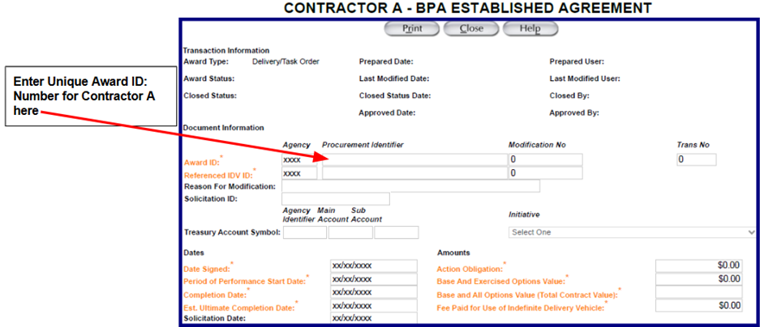
Step 2 Record the Referenced IDV ID: Number for the OASIS+ for Contractor A (*This is unique to Contractor A)
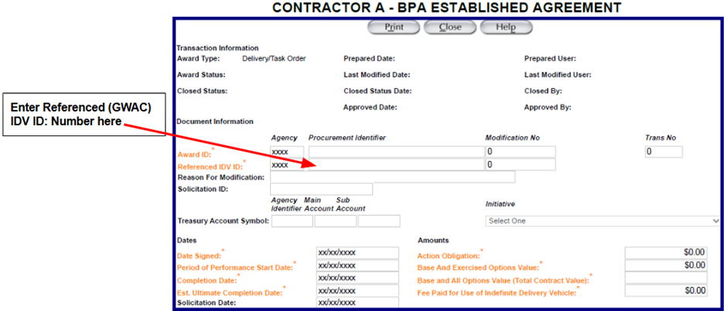
Step 3 Record the Solicitation ID: Number for the BPA Established Agreement (* Solicitation ID
Number will be the same for both Contractor A and B)
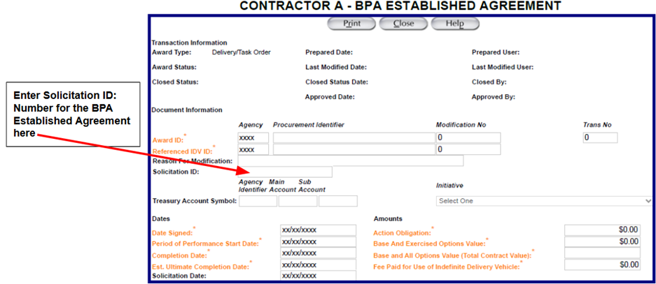
Step 4 Record the Estimated Value of the BPA Established Agreement (* Estimated Value will be the same for both Contractor A and B)
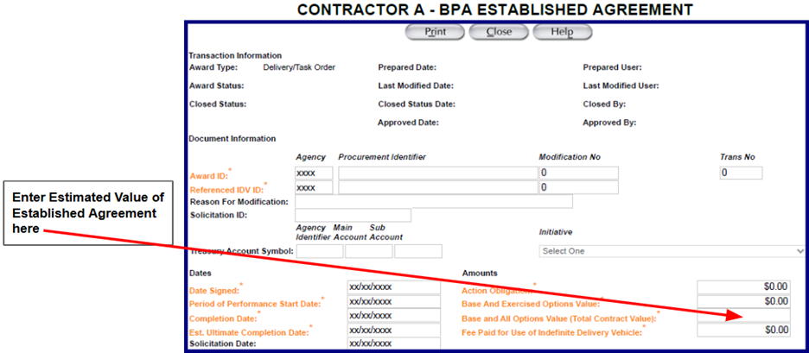
Step 5 Include a description for the BPA Established Agreement, Contractor A’s BPA Award Number, Total Period of Performance (Base + Option Periods), and Total Estimated Value
You will repeat the same steps above for Contractor B
Step 1 Record the BPA Established Agreement Number for Contractor B
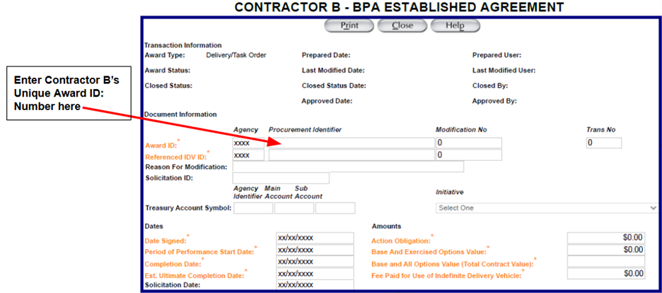

Step 2 Record the Referenced IDV ID: Number for the OASIS+ for Contractor B (*This is unique to Contractor B)
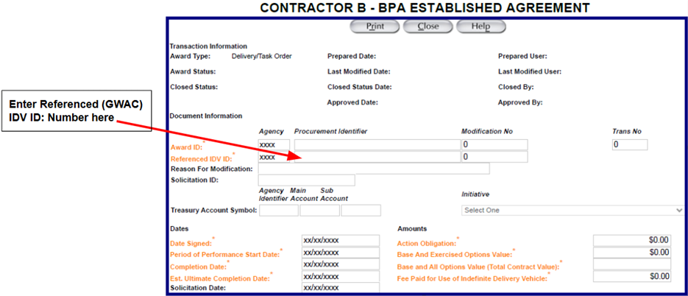

Step 3 Record the Solicitation ID: Number for the BPA Established Agreement (* Solicitation ID Number will be the same for both Contractor B and A)
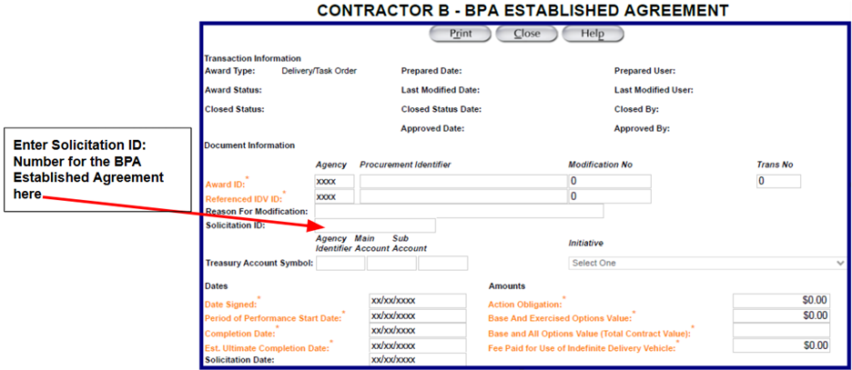
Step 4 Record the Estimated Value of the BPA Established Agreement (* Estimated Value will be the same for both Contractor B and A)
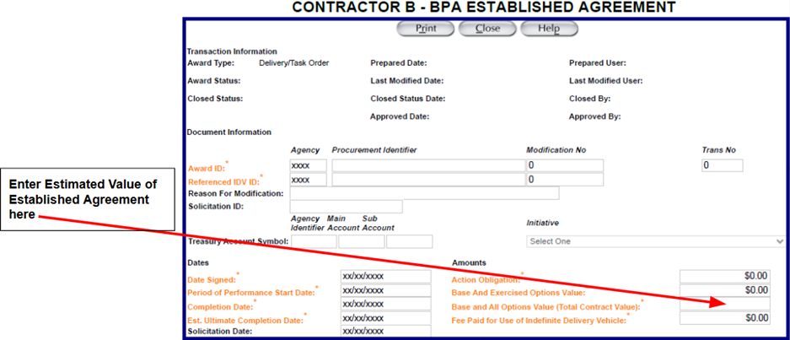
Step 5 Include a description for the BPA Established Agreement, Contractor B’s BPA Award Number, Total Period of Performance (Base + Option Periods), and Total Estimated Value
Contractor A BPA Order/Call from Multiple Award above
- FPDS Reporting Example:
The steps below cover the main points this office recommends for tracking purposes, but they do not include all the required fields needed to complete the FPDS submittal.
Step 1 Record the BPA order/call to Contractor A in the Award ID: Field in FPDS
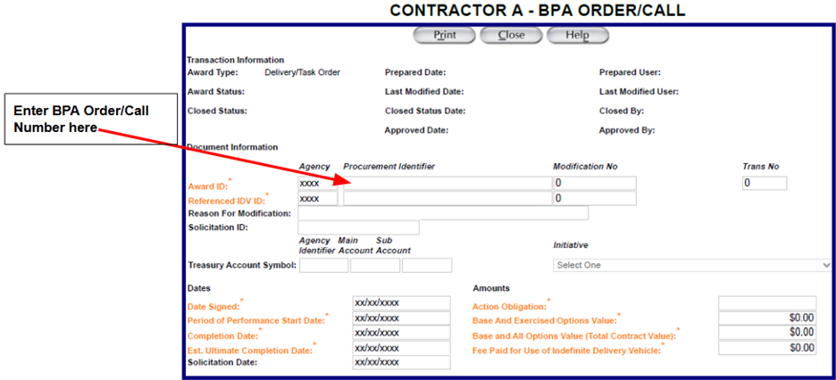
Step 2 Enter Contractor A’s OASIS+ number in the Referenced IDV ID: Field in FPDS
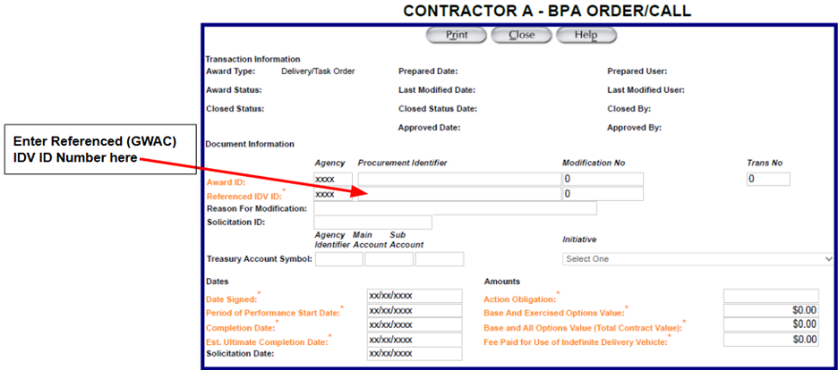

Step 3 Enter the BPA Order/Call Solicitation number in the Solicitation ID: Field in FPDS
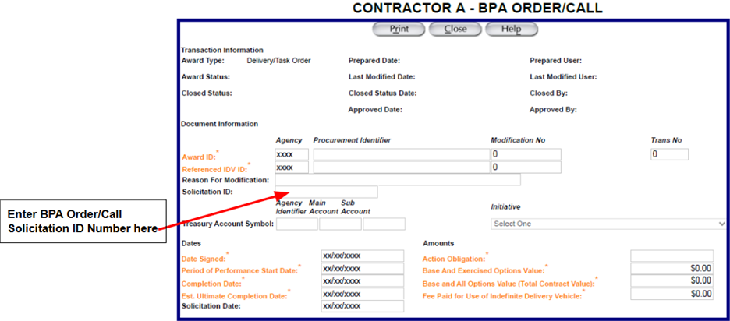
Step 4 Enter the BPA Order/Call Award Obligation Amount in the Action Obligation field in FPDS
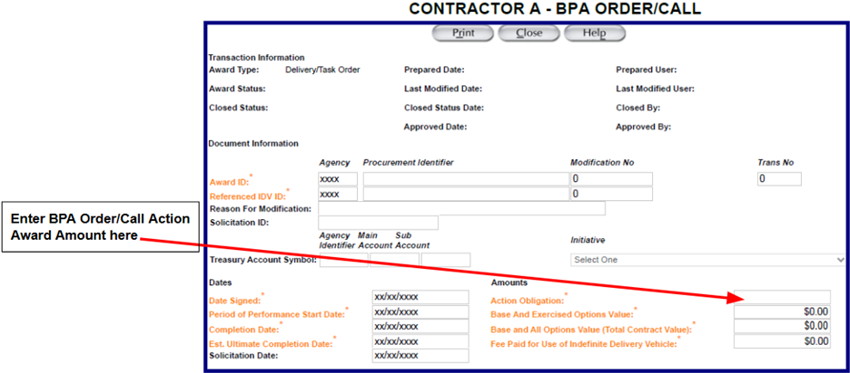
Step 5 Include additional information in the Description Field

