

**U.S. General Services Administration**

Federal Acquisition Service

**­­**

**GSA Transition Coordination Center**

**EIS Transition Progress Tracking Report**

**for the period ending March 31, 2024**

**Version 1.0**

**April 24, 2024**

**DTID: #TCC3-ASC-0500A-20240424-00**

PREPARED FOR

**Transition Coordination Center**

**General Services Administration**

**Federal Acquisition Service**

**1800 F Street NW**

**Washington, DC 20405**

Contract Number: GS-35F-500CA

**Order Number:** **47QTCB24F0002**

**Executive Summary**

This Executive Summary provides an overview of transition progress that will be discussed in detail within this report.

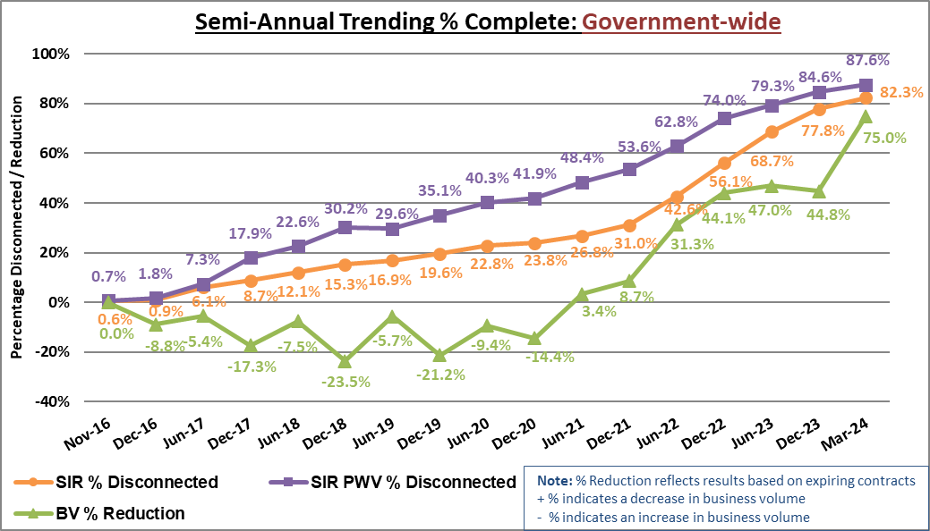

***Semi-Annual Trending % Complete: Government-wide***

***Transition Progress Metrics Summary: Agency Category***

| **Transition Progress Metrics Summary: Agency Category** | | | | | | |
| --- | --- | --- | --- | --- | --- | --- |
| **Tracking Metric** | **Date Due** | **Percentage Complete** | **Total Count** | **Large Agencies Count** | **Medium Agencies Count** | **Small Agencies Count** |
| **Total EIS Solicitations Planned 🡪** | | | **209** | **107** | **43** | **59** |
| EIS Solicitations Passed GSA In-Scope Review | 3/31/2019 | 100.0% | 209 | 107 | 43 | 59 |
| EIS Solicitations Issued to Industry | 3/31/2019 | 100.0% | 209 | 107 | 43 | 59 |
| Task Orders Awarded (as defined by Key Metric) | 9/30/2019 | 99.5% | 208 | 106 | 43 | 59 |
| **Total Agencies 🡪** | | | **221** | **17** | **25** | **179** |
| Transition 50% Complete (PWV disconnects ≥50% & <90%) | 3/31/2021 | 13.6% | 30 | 10 | 5 | 15 |
| Transition 90% Complete (PWV disconnects ≥90% & <100%) | 3/31/2022 | 14.0% | 31 | 7 | 7 | 17 |
| Transition 100% Complete (Disconnects =100%) | 9/30/2022 | 69.7% | 154 | 0 | 13 | 141 |

This Key identifies the markings used in the EIS Transition Progress table below.

Key shows markings used for the figure labeled EIS Transition Progress: Large and Medium Agencies. Pink represents SIR PWV percent disconnected less than 50. Orange represents SIR PWV percent  disconnected equal to or greater than fifty but less than ninety percent. Yellow represents SIR PWV percent disconnected equal to or greater than ninety but less than one hundred percent. Green represents SIR PWV percent disconnected equal to one hundred.  

***EIS Transition Progress: Large and Medium Agencies*** This table provides SIR PWV % disconnected progress for large and medium agencies.

**Document Change History**

| **Version** | **Description** | **Date** | **Prepared By** |
| --- | --- | --- | --- |
| 1.0 | Original Submission | 04/24/2024 | Ken Palmer |

**Table of Contents**

1 Introduction 6

1.1 Purpose 6

1.2 Understanding the TPTR 6

1.3 Agency Categories and Size Standards 6

1.4 Scope 6

2 Overall Status 7

2.1 Transition Summary 8

2.2 Transition Volume 8

2.3 Transition Progress - Large and Medium Agencies 10

3 Detailed Transition Progress Status Measurements 12

3.1 Transition Progress Metrics 12

3.2 Transition Progress – Government-wide 13

3.3 Transition Progress – Program 15

3.4 Transition Progress - Contractor 17

3.5 Transition Progress – Agency Category 20

3.5.1 Transition Progress - Large Agencies 22

3.5.2 Transition Progress – Medium Agencies 24

3.5.3 Transition progress - Small Agencies 26

3.6 Transition progress – Service Category 26

4 Risk Management 27

4.1 Lessons Learned 27

4.2 Risk Assessment 27

Appendix A – EIS Transition Progress: Small Agencies 30

Appendix B – Transition Completion Status 35

Appendix C – Key Metrics 39

Appendix D – Key Definitions 40

Appendix E – Acronyms 42

Appendix F – Service Type Standardization and Proportional Weighted Values 44

**List of Tables**

Table 1. *Transition Progress Metrics Summary: Agency Category* 8

Table 2. *EIS Transition Progress: Large Agencies* 10

Table 3. *EIS Transition Progress: Medium Agencies* 11

Table 4. *EIS Transition Progress: Government-wide* 13

Table 5. *EIS Transition Progress: Program* 15

Table 6.  *EIS Transition Progress: Contractor* 18

Table 7. *EIS Transition Progress: Agency Category* 20

Table 8. *EIS Transition Progress: Service Category* 26

Table 9. *Transition Risks and Mitigation* 28

**List of Figures**

Figure 1. *Transition Progress Milestones Gantt Chart* 7

Figure 2. *SIR # Active and % of Government-wide SIR # Active: Agency Category* 9

Figure 3. *BV $ Current and % of Government-wide BV $ Current: Agency Category* 9

Figure 4. *Semi-Annual Trending % Complete: Government-wide* 13

Figure 5.  *SIR # Active and SIR # Disconnected: Government-wide* 14

Figure 6.  *BV $ Current and BV $ Reduction: Government-wide* 14

Figure 7. *Semi-Annual Trending – SIR PWV % Disconnected: Program* 15

Figure 8. *Semi-Annual Trending - BV % Reduction: Program* 16

Figure 9. *SIR Active # and % of Government-wide SIR # Active: Program* 16

Figure 10. *BV $ Current and % of Government-wide BV $ Current: Program* 17

Figure 11. *Semi-Annual Trending - SIR PWV % Disconnected: Contractor* 18

Figure 12. *Semi-Annual Trending - BV % Reduction: Contractor* 19

Figure 13. *SIR Active # and % of Government-wide SIR # Active: Contractor* 19

Figure 14. *BV $ Current and % of Government-wide BV $ Current: Contractor* 20

Figure 15. *Semi-Annual Trending - SIR % Disconnected: Agency Category* 21

Figure 16. *Semi-Annual Trending - SIR PWV % Disconnected: Agency Category* 21

Figure 17*. Semi-Annual Trending - BV % Reduction: Agency Category* 22

Figure 18. *SIR % and* *SIR PWV % Disconnected: Large Agencies* 22

Figure 19. *SIR # Active – Baseline to Current: Large Agencies* 23

Figure 20. *SIR PWV # Active – Baseline to Current: Large Agencies* 23

Figure 21. *SIR % and SIR PWV % Disconnected: Medium Agencies* 24

Figure 22. *SIR # Active – Baseline to Current: Medium Agencies* 25

Figure 23. *SIR PWV # Active – Baseline to Current: Medium Agencies* 25

Figure 24. *Current Status of Transition Metrics: Service Category* 27

# Introduction

## Purpose

The General Services Administration (GSA) Enterprise Infrastructure Solutions (EIS) *Transition Progress Tracking Report* *(TPTR)* provides a monthly overview of transition progress from the expiring Networx, Washington Interagency Telecommunications System (WITS) 3, and GSA Regional local service (RLS) contracts to EIS or other contract vehicles. Progress is based upon an analysis of agency decisions and activities that indicate the level of preparedness for transition; the status of contract services agencies must disconnect; the business volume (BV) on each expiring contract; and challenges that may impact agencies’ timely completion of transition.

## Understanding the TPTR

Stakeholders should refer to the Transition Progress Tracking Methodology (TPTM) for a more in-depth description of the process, tools, and metrics included in this report. A description of key metrics from the TPTM is provided in Appendix C.

## Agency Categories and Size Standards

There are over 200 agencies with Transition Inventory (TI) and billing under the expiring contracts. For this report, agencies are categorized into three groups: large agencies, medium agencies, and small agencies as defined by their average annual BV on the Networx contracts in Fiscal Year (FY) 12 through FY15.

* Large agencies: 17 agencies with annual BV ≥ $10 million
* Medium agencies: 25 agencies with annual BV < $10 million but ≥ $1 million
* Small agencies:  179 agencies with annual BV < $1 million (Includes 117 agencies plus 62 Native American Tribes; Agency count [117] includes GSA-Regional Internal under AB code 0047).

For reporting, an “agency” is defined as a “transition entity.” Transition entities are specified in the Transition Entities List located on the EIS Transition/Transition Resources webpage, under Guides/Resources (<https://www.gsa.gov/technology/technology-purchasing-programs/telecommunications-and-network-services/enterprise-infrastructure-solutions/eis-transition/transition-resources>).

## Scope

The TPTR uses actual and target metrics to track transition progress at various levels: Government-wide, Program, Contractor, Agency Category, and Service Category. This month’s report is derived from acquisition planning and decision data, TI data, and other supporting data as of March 31, 2024. BV reflects data as of February 29, 2024.

# Overall Status

Figure 1 illustrates the established target dates for key milestones (defined in Appendix C) and other measurements for tracking transition progress. Subsequent subsections provide a snapshot of progress against transition metrics. For any extensions beyond the May 2024 deadline, GSA will continue to track those agencies to completion and meet with them regularly to monitor status.

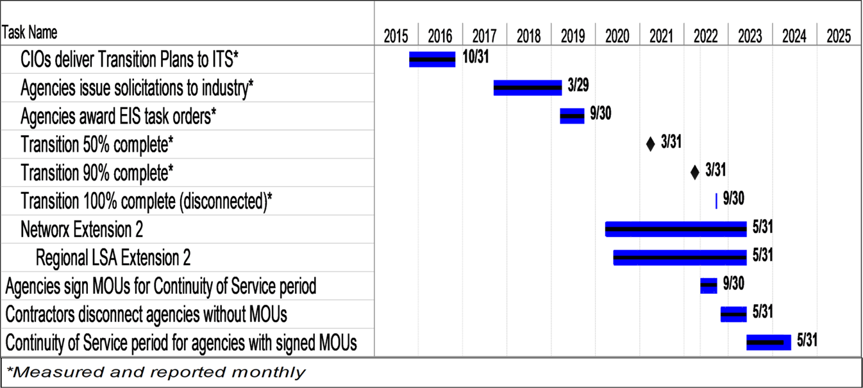

Figure 1. *Transition Progress Milestones Gantt Chart*

## Transition Summary

Table 1 provides a summary of transition progress metrics by agency category. Agencies were to have disconnected 100% of services from expiring contracts as reported by Networx contractors, WITS 3 Project Management Office (PMO), and the Telecommunications Ordering and Pricing System (TOPS) by the date due listed. A service is represented as a “Service Instance Record (SIR),” which is a summarized rollup of a base service and the associated equipment, features, and other ancillary Contract Line-Item Numbers (CLINs). Transition entities and GSA use SIRs to track the progress of transition from Networx, WITS 3, and GSA RLS contracts. When SIRs are weighted based on their complexity to transition, it is referred to as SIR Proportional Weighted Value (PWV).

Table 1. *Transition Progress Metrics Summary: Agency Category*

| **Transition Progress Metrics Summary: Agency Category** | | | | | | |
| --- | --- | --- | --- | --- | --- | --- |
| **Tracking Metric** | **Date Due** | **Percentage Complete** | **Total Count** | **Large Agencies Count** | **Medium Agencies Count** | **Small Agencies Count** |
| **Total EIS Solicitations Planned 🡪** | | | **209** | **107** | **43** | **59** |
| EIS Solicitations Passed GSA In-Scope Review | 3/31/2019 | 100.0% | 209 | 107 | 43 | 59 |
| EIS Solicitations Issued to Industry | 3/31/2019 | 100.0% | 209 | 107 | 43 | 59 |
| Task Orders Awarded (as defined by Key Metric) | 9/30/2019 | 99.5% | 208 | 106 | 43 | 59 |
| **Total Agencies 🡪** | | | **221** | **17** | **25** | **179** |
| Transition 50% Complete (PWV Disconnects ≥50% & <90%) | 3/31/2021 | 13.6% | 30 | 10 | 5 | 15 |
| Transition 90% Complete (PWV Disconnects ≥90% & <100%) | 3/31/2022 | 14.0% | 31 | 7 | 7 | 17 |
| Transition 100% Complete (Disconnects =100%) | 9/30/2022 | 69.7% | 154 | 0 | 13 | 141 |

## Transition Volume

Transition volume provides a count of active SIRs in TI during the current period. Since the volume of active SIRs and current BV are indicators of agency transition completion status, GSA’s TCC will report on the volume of active services remaining on expiring contracts and the associated BV until both volumes are zero and there are no remaining charges.

Figure 2 illustrates the active SIR count by agency category as a percentage of the Government-wide active SIR count.

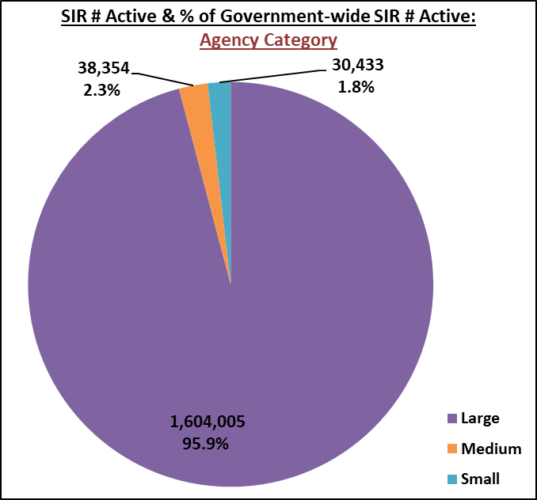

Figure 2. *SIR # Active and % of Government-wide SIR # Active: Agency Category*

Figure 3 illustrates the current BV amount ($) by agency category as a percentage of the Government-wide current BV amount ($).

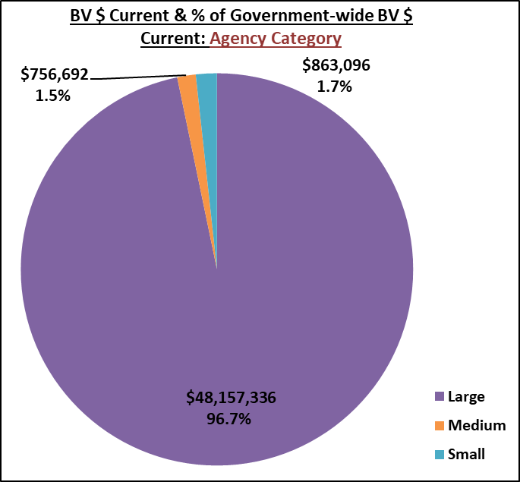

Figure 3. *BV $ Current and % of Government-wide BV $ Current: Agency Category*

## Transition Progress - Large and Medium Agencies

Tables 2 and 3 provide the status of transition progress of the large and medium agencies. The difference between the total SIR count and the number of active SIRs is divided by the total SIR count to calculate the SIR percentage disconnected; this is shown alongside the SIR PWV percentage disconnected, which factors in complexity. The current BV amount ($) is compared to the initial BV amount ($) from November 2016 to calculate BV percentage reduction. Note that the BV % reduction can exceed 100% when the current month’s data contains credit adjustments greater than the billing charges.

This Key identifies the markings used in the EIS Transition progress tables.

Key shows markings used for the figure labeled EIS Transition Progress: Large Agencies and EIS Transition Progress: Medium  Agencies. The colors noted below apply to SIR % disconnected, SIR PWV % disconnected, and BV % reduction.  Pink represents percents  less than 50. Orange represents percents equal to or greater than 50 but less than 90. Yellow represents percents equal to or greater than 90 but less than 100. Green represents percents equal to 100.  

Table 2. *EIS Transition Progress: Large Agencies*

Table 2 illustrates the EIS transition progress for large agencies by SIR % disconnected, SIR PWV % disconnected, and BV % reduction.

Table 3. *EIS Transition Progress: Medium Agencies*

Table 3 illustrates the EIS transition progress for medium agencies by SIR % disconnected, SIR PWV % disconnected, and BV % reduction.  
‘

# Detailed Transition Progress Status Measurements

This section provides additional details on the activities associated with each metric driving the results on the EIS Transition Progress tables in Section 2.3 and at other tracking levels. Agencies were required to follow a fair opportunity (FO) process to issue solicitations to industry and award at least one task order (TO) against each FO solicitation. Once the EIS TOs are awarded, agencies work directly with EIS contractors to execute the transition of services. Transition is considered complete when all SIRs from expiring contracts have been disconnected and BV has been reduced to zero (also reported as BV *reduction* = 100%) and there are no remaining charges. These metrics are tracked at the following tracking levels: Government-wide, Program, Contractor, Agency Category (Large, Medium, Small), and Service Category.

## Transition Progress Metrics

This section provides an overview of the metrics used to track and report transition progress.

**Disconnect/Transition of SIRs:** The SIR # Disconnected refers to the difference in the current month’s data of counts from the SIR # Total count and the SIR # Active count. The SIR % Disconnected is tracked and reported by dividing the current month SIR # Disconnected counts by the SIR # Total count. The SIR # Total includes all SIRs (active and disconnects) including new SIRs that were added to TI since the prior reporting period. Thus, the denominator for percent disconnected is always the most current SIR # Total, which allows the goal to remain as 100% disconnected.

**Disconnect/Transition of SIR PWV:** Progress for SIRs with PWV is tracked and reported similarly to SIRs. PWV is assigned to services based on the relative difficulty of transitioning that service. The SIR # Disconnected counts for each service are multiplied by the appropriate weighted value for that service and the resulting values summed; that numerator is divided by the total weighted value of the SIRs to calculate the weighted percent disconnected. The SIR PWV % Disconnected is tracked and reported by dividing the current month SIR # Disconnected count, with weighted values applied, by the SIR # Total count, with weighted values applied. See Appendix F for the PWVs applied to each service.

**Business Volume (BV) Reduction:** The BV Reduction metric compares the initial BV to current BV monthly. The BV $ Initial refers to the BV total as of November 1, 2016. The BV $ Current refers to the BV total as of the end of the current reporting month. ***Note:*** Services could be 100% disconnected while BV is still > 0. Also, BV is affected by many factors other than disconnects, such as billing adjustments and usage fluctuations, and therefore could increase or decrease with no correlation to transition progress.

## Transition Progress – Government-wide

This section identifies transition progress Government-wide for the following metrics: SIR disconnected, SIR PWV disconnected, and BV reduction.

Table 4 and Figure 4 illustrate the status and trending of transition progress Government-wide. The difference between the total SIR count and the number of active SIRs is divided by the total SIR count to calculate the SIR percentage disconnected; this is shown alongside the SIR PWV percentage disconnected which factors in complexity. The current BV amount ($) is compared to the initial BV amount ($) to calculate BV percentage reduction.

Table 4. *EIS Transition Progress: Government-wide*

|  |  |  |  |  |  |  |  |
| --- | --- | --- | --- | --- | --- | --- | --- |
| **EIS Transition Progress: Government-wide** | | | | | | | |
| **Category** | **Service Instance Records** | | | | **Business Volume** | | |
| **SIR # Total** | **SIR # Active** | **SIR % Disconnected** | **SIR PWV % Disconnected** | **BV $ Initial** | **BV $ Current** | **BV % Reduction** |
| **Government-wide** | **9,454,166** | **1,672,792** | **82.3%** | **87.6%** | **$199,055,190** | **$49,777,124** | **75.0%** |



Figure 4. *Semi-Annual Trending % Complete: Government-wide*

Figure 5 illustrates the number of active SIRs and the number of disconnected SIRs as percentages of the Government-wide total SIR count.

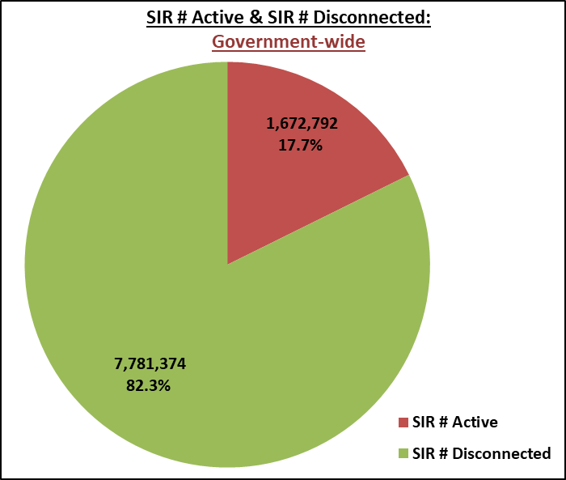

Figure 5.  *SIR # Active and SIR # Disconnected: Government-wide*

Figure 6 illustrates the current BV amount ($) and the BV reduction amount ($) as percentages of the Government-wide total BV amount ($).

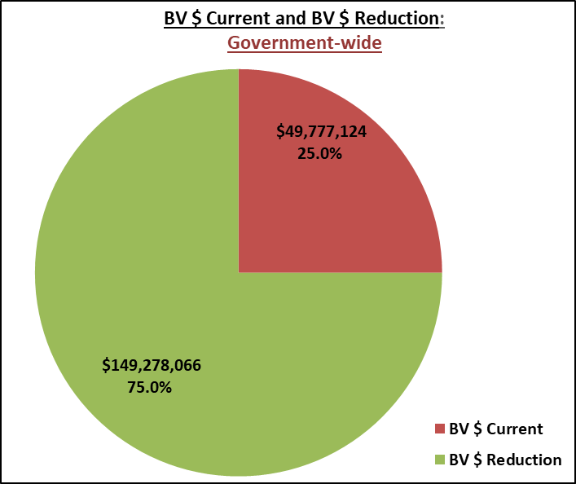

Figure 6.  *BV $ Current and BV $ Reduction: Government-wide*

## Transition Progress – Program

This section identifies transition progress by program including Networx (Universal and Enterprise), WITS 3, and the GSA RLS (where all GSA RLS contracts are grouped together) for the following metrics: SIR disconnected, SIR PWV disconnected, and BV reduction.

Table 5 and Figures 7-10 illustrate the status and trending of transition progress by program. The difference between the total SIR count and the number of active SIRs is divided by the total SIR count to calculate the SIR percentage disconnected; this is shown alongside the SIR PWV percentage disconnected which factors in complexity. The current BV amount ($) is compared to the initial BV amount ($) to calculate BV percentage reduction.

Table 5. *EIS Transition Progress: Program*

| **EIS Transition Progress: Program** | | | | | | | |
| --- | --- | --- | --- | --- | --- | --- | --- |
| **Program** | **Service Instance Records** | | | | **Business Volume** | | |
| **SIR # Total** | **SIR # Active** | **SIR % Disconnected** | **SIR PWV % Disconnected** | **BV $ Initial** | **BV $ Current** | **BV % Reduction** |
| Networx | 7,323,488 | 1,251,874 | 82.9% | 86.2% | $154,091,619 | $33,141,573 | 78.5% |
| WITS 3 | 1,236,703 | 141,063 | 88.6% | 94.5% | $35,257,099 | $12,825,029 | 63.6% |
| GSA RLS | 893,975 | 279,855 | 68.7% | 79.2% | $9,706,472 | $3,810,522 | 60.7% |
| **TOTALS** | **9,454,166** | **1,672,792** | **82.3%** | **87.6%** | **$199,055,190** | **$49,777,124** | **75.0%** |

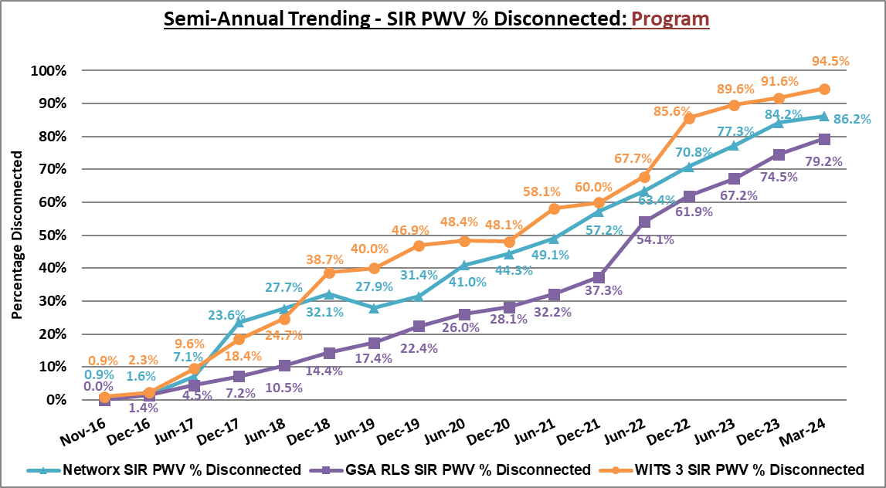

Figure 7. *Semi-Annual Trending – SIR PWV % Disconnected: Program*

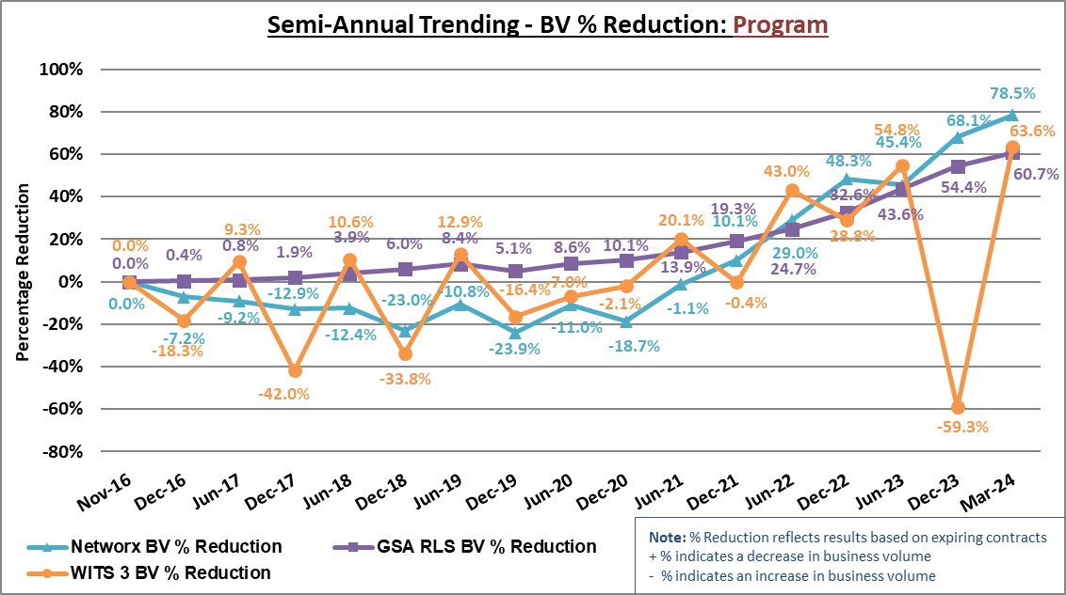

Figure 8. *Semi-Annual Trending - BV % Reduction: Program*

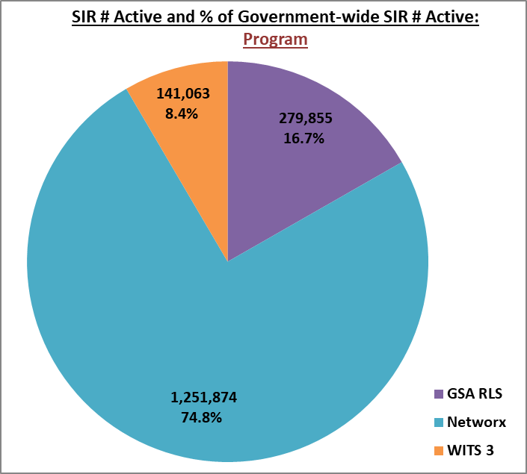

Figure 9. *SIR Active # and % of Government-wide SIR # Active: Program*

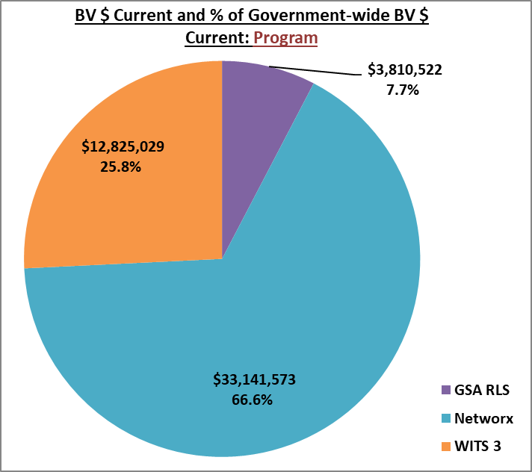

Figure 10. *BV $ Current and % of Government-wide BV $ Current: Program*

## Transition Progress - Contractor

This section identifies transition progress by contractor including Networx and WITS 3 contractors (American Telephone & Telegraph (AT&T), CenturyLink, Level 3, Sprint, and Verizon), and GSA RLS contracts for the following metrics: SIR disconnected, SIR PWV disconnected, and BV reduction.

**Note:** *WITS 3 and GSA RLS contracts include the local services that are interexchanged to long distance services under the Networx program.*

Table 6 and Figures 11-14 illustrate the status and trending of transition progress by contractor. The difference between the total SIR count and the number of active SIRs is divided by the total SIR count to calculate the SIR percentage disconnected; this is shown alongside the SIR PWV percentage disconnected which factors in complexity. The current BV amount ($) is compared to the initial BV amount ($) to calculate BV percentage reduction.

**Note:** *The Sprint Networx Enterprise contract has expired; therefore, Sprint does not appear in the supporting quarterly trending figures as any fluctuations would be minor.*

Table 6.  *EIS Transition Progress: Contractor*

| **EIS Transition Progress: Contractor** | | | | | | | |
| --- | --- | --- | --- | --- | --- | --- | --- |
| **Contractor** | **Service Instance Records** | | | | **Business Volume** | | |
| **SIR # Total** | **SIR # Active** | **SIR % Disconnected** | **SIR PWV % Disconnected** | **BV $ Initial** | **BV $ Current** | **BV % Reduction** |
| **Verizon** | 5,949,607 | 886,552 | 85.1% | 89.8% | $91,952,661 | $32,333,625 | 64.8% |
| **AT&T** | 1,246,459 | 192,927 | 84.5% | 95.8% | $64,498,470 | $3,956,898 | 93.9% |
| **CenturyLink** | 1,151,802 | 260,792 | 77.4% | 78.3% | $22,128,763 | $3,504,827 | 84.2% |
| **GSA RLS** | 893,975 | 279,855 | 68.7% | 79.2% | $9,706,472 | $3,810,522 | 60.7% |
| **Level 3** | 162,612 | 52,666 | 67.6% | 83.8% | $10,128,788 | $6,171,252 | 39.1% |
| **Sprint** | 49,711 | - | 100.0% | 100.0% | $640,035 | $0 | 100.0% |
| **TOTALS** | **9,454,166** | **1,672,792** | **82.3%** | **87.6%** | **$199,055,190** | **$49,777,124** | **75.0%** |

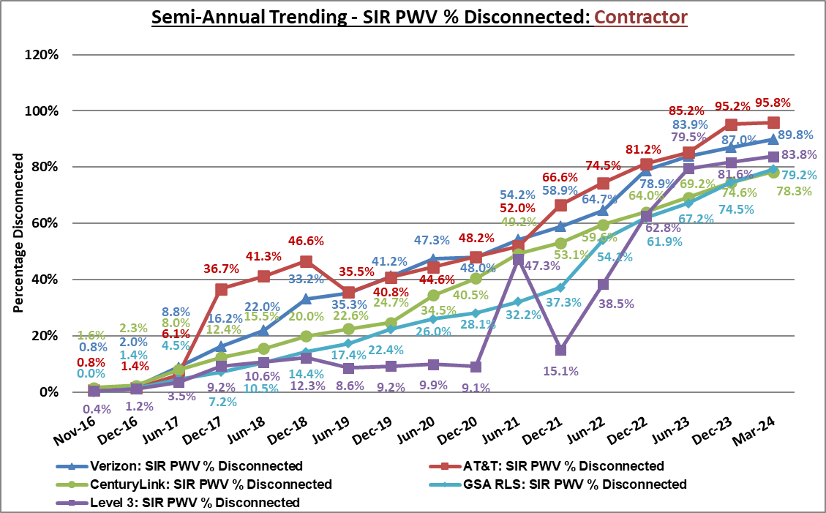

Figure 11. *Semi-Annual Trending - SIR PWV % Disconnected: Contractor*

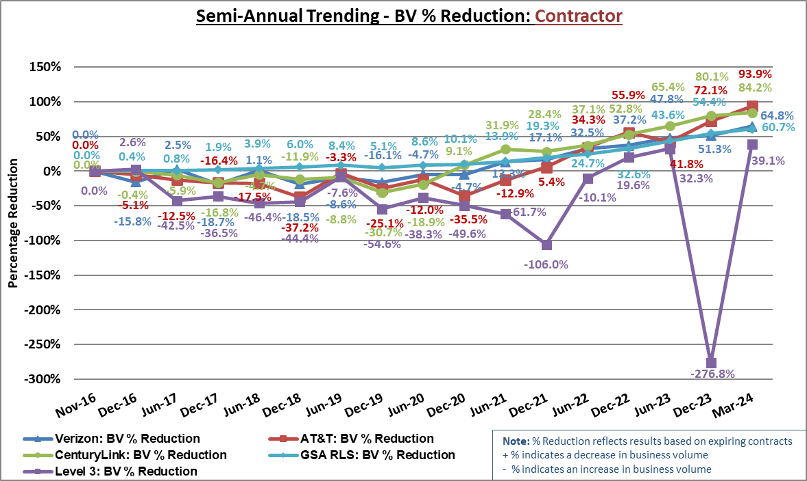

Figure 12. *Semi-Annual Trending - BV % Reduction: Contractor*

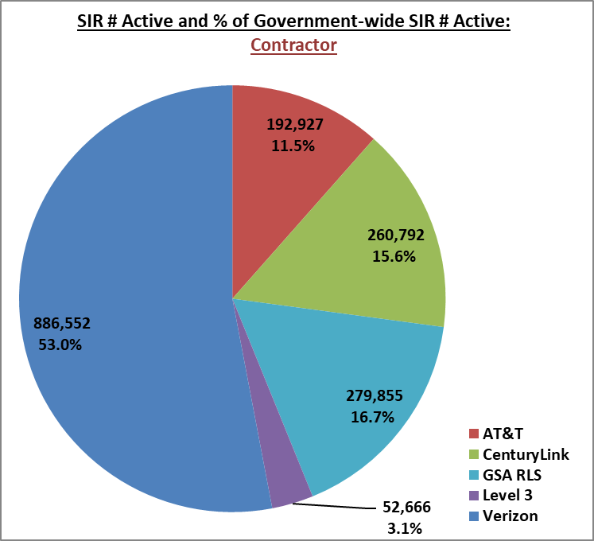

Figure 13. *SIR Active # and % of Government-wide SIR # Active: Contractor*

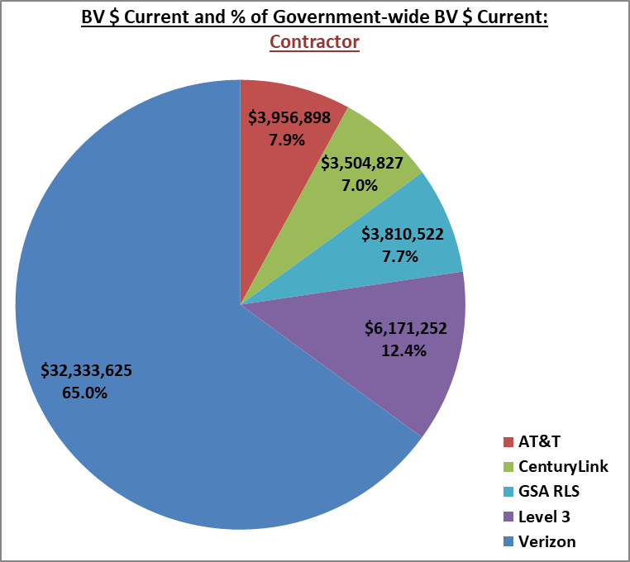

Figure 14. *BV $ Current and % of Government-wide BV $ Current: Contractor*

## Transition Progress – Agency Category

This section identifies transition progress by agency category (see Section 1.3) for the following metrics: SIR disconnected, SIR PWV disconnected, and BV reduction. References to baseline active SIR values refer to the count of active SIRs in TI on November 1, 2016. Likewise, references to baseline active SIR PWV refer to the count of active SIRs in TI on November 1, 2016, where services were multiplied by the appropriate weighted value and resulting values were summed.

Table 7 and Figures 15-17 illustrate the status and trending of transition progress by agency category. The difference between the total SIR count and the number of active SIRs is divided by the total SIR count to calculate the SIR percentage disconnected; this is shown alongside the SIR PWV percentage disconnected which factors in complexity. The current BV amount ($) is compared to the initial BV amount ($) to calculate BV percentage reduction.

Table 7. *EIS Transition Progress: Agency Category*

|  |  |  |  |  |  |  |  |
| --- | --- | --- | --- | --- | --- | --- | --- |
| **EIS Transition Progress: Agency Category** | | | | | | | |
| **Agency Category** | **Service Instance Records** | | | | **Business Volume** | | |
| **SIR # Total** | **SIR # Active** | **SIR % Disconnected** | **SIR PWV % Disconnected** | **BV $ Initial** | **BV $ Current** | **BV % Reduction** |
| **Large** | 8,561,249 | 1,604,005 | 81.3% | 87.5% | $186,018,570 | $48,157,336 | 74.1% |
| **Medium** | 620,109 | 38,354 | 93.8% | 92.6% | $9,306,888 | $756,692 | 91.9% |
| **Small** | 272,808 | 30,433 | 88.8% | 82.7% | $3,729,732 | $863,096 | 76.9% |
| **TOTALS** | **9,454,166** | **1,672,792** | **82.3%** | **87.6%** | **$199,055,190** | **$49,777,124** | **75.0%** |

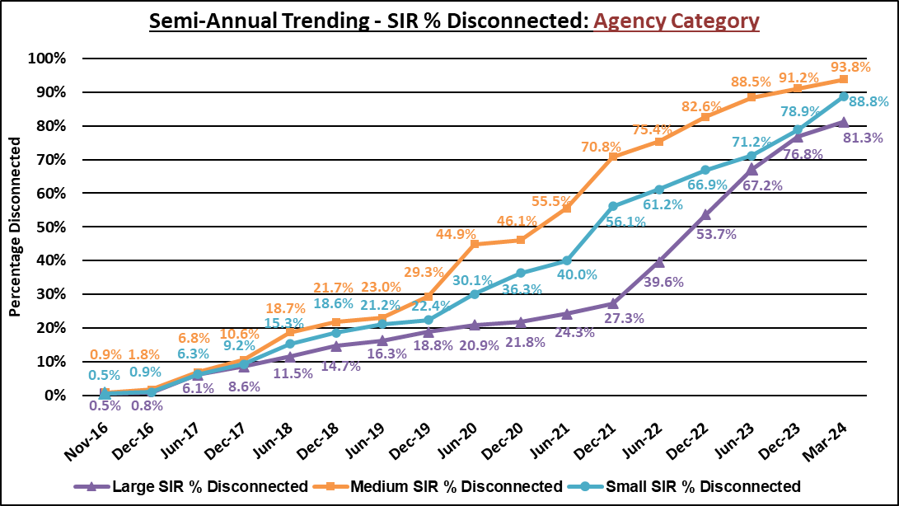

Figure 15. *Semi-Annual Trending - SIR % Disconnected: Agency Category*

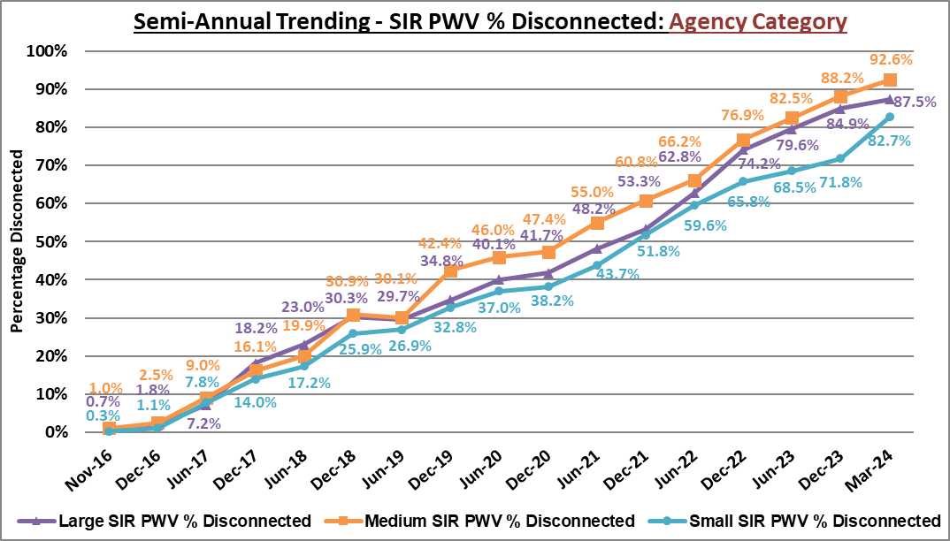

Figure 16. *Semi-Annual Trending - SIR PWV % Disconnected: Agency Category*

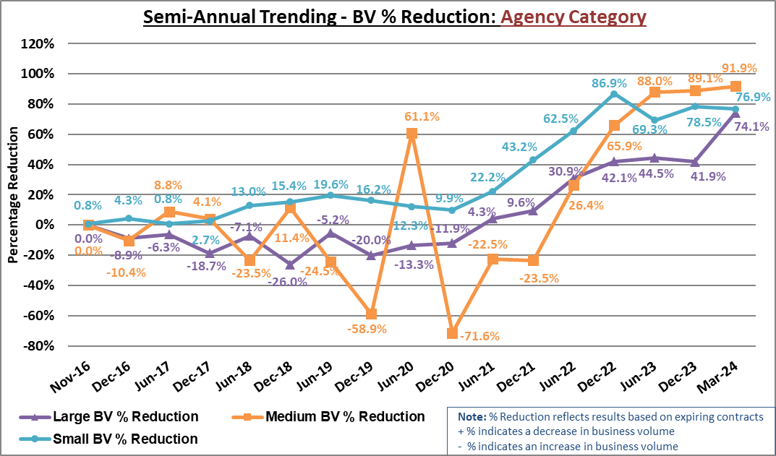

Figure 17*. Semi-Annual Trending - BV % Reduction: Agency Categor**y*

### 3.5.1 Transition Progress - Large Agencies

Figure 18 illustrates SIR and SIR PWV percentages disconnected for each of the large agencies.

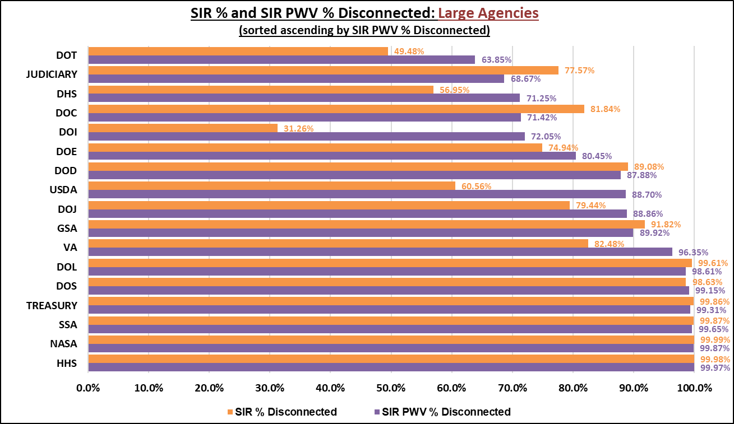

Figure 18. *SIR % and* *SIR PWV % Disconnected: Large Agencies*

Figure 19 illustrates the comparison between the baseline active SIR count and current active SIR count for each of the large agencies.

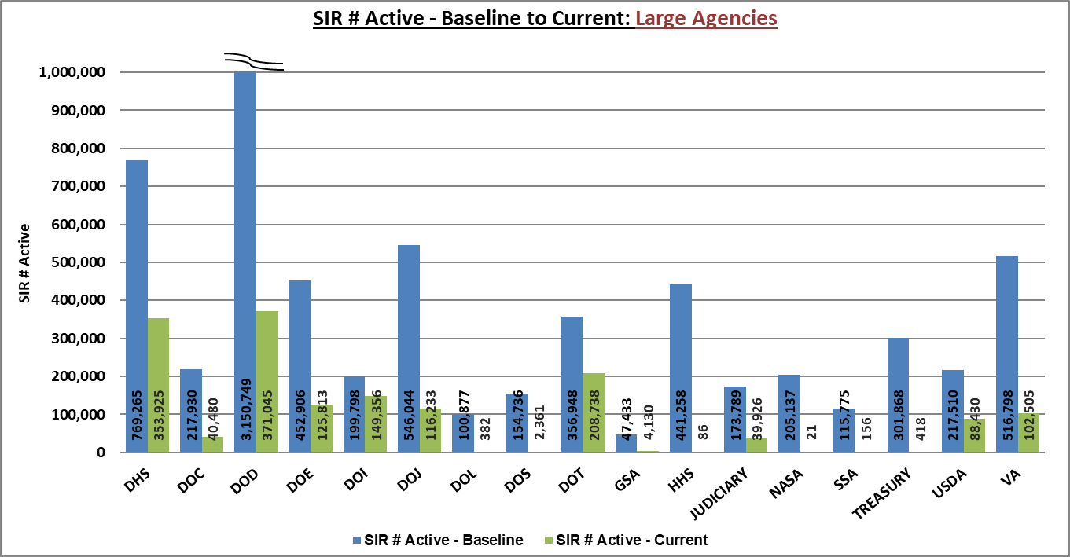

Figure 19. *SIR # Active – Baseline to Current: Large Agencies*

Figure 20 illustrates the comparison between the baseline active SIR PWV count and current active SIR PWV count for each of the large agencies.

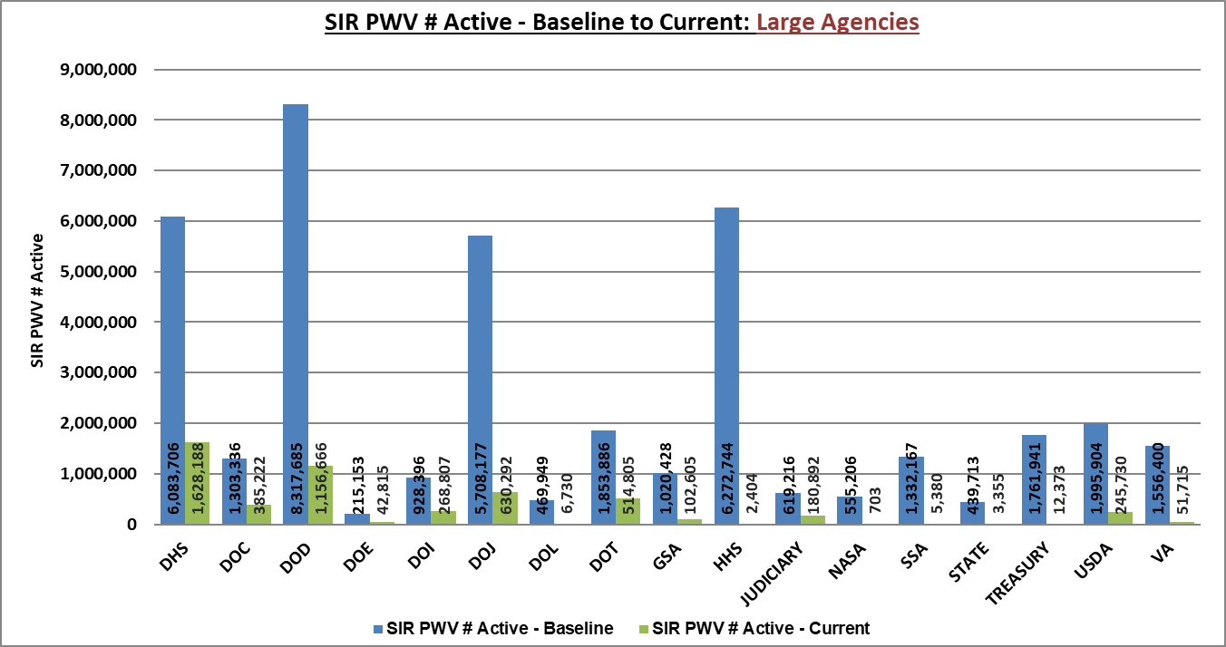

Figure 20. *SIR PWV # Active – Baseline to Current: Large Agencies*

### 3.5.2 Transition Progress – Medium Agencies

Figure 21 illustrates the SIR and SIR PWV percentages disconnected for each of the medium agencies.

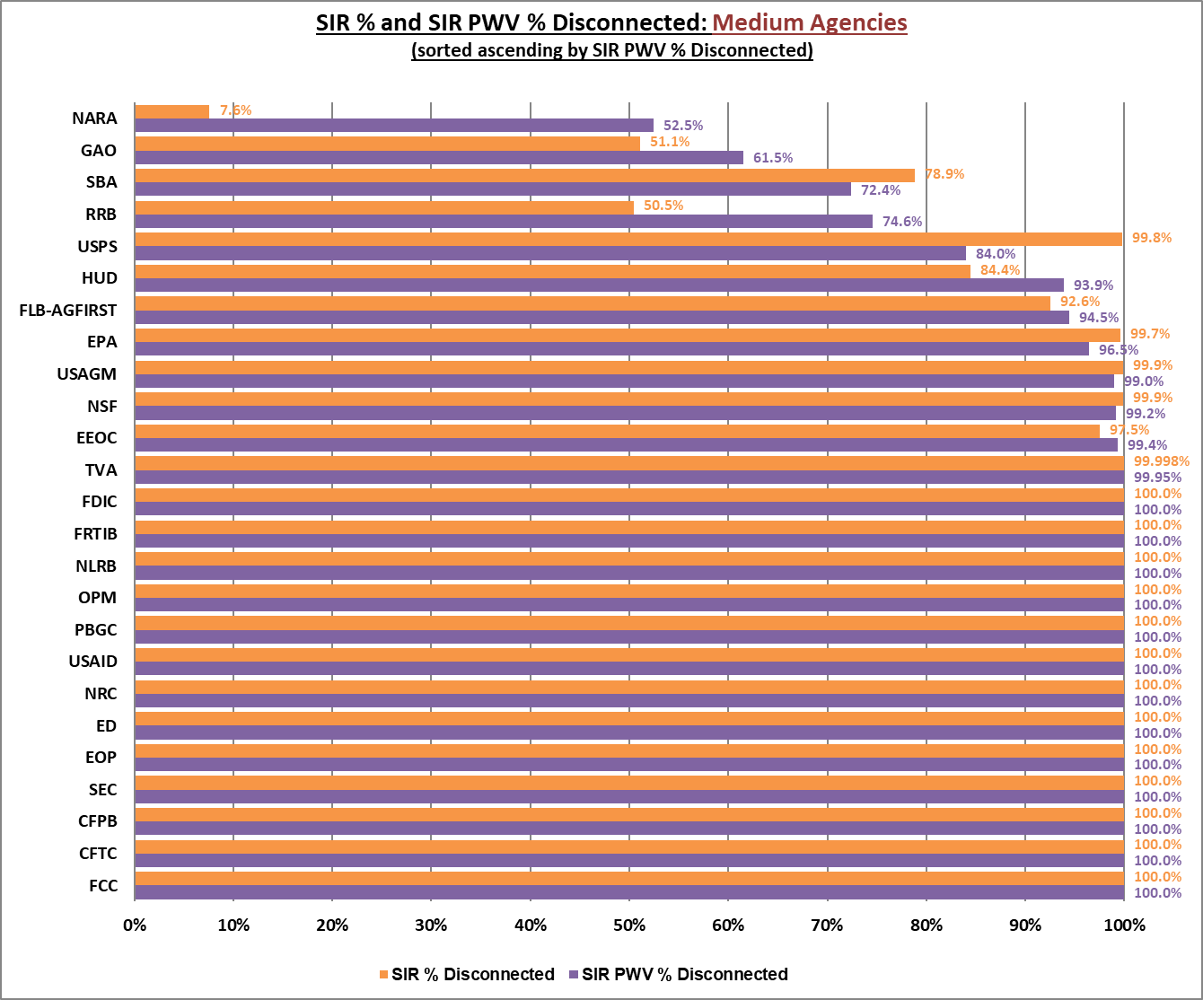

Figure 21. *SIR % and SIR PWV % Disconnected: Medium Agencies*

Figure 22 illustrates the comparison between the baseline active SIR count and current active SIR count for each of the medium agencies.

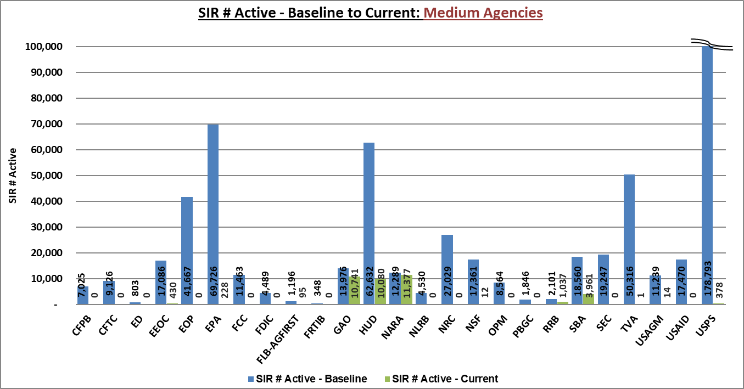

Figure 22. *SIR # Active – Baseline to Current: Medium Agencies*

Figure 23 illustrates the comparison between the baseline active SIR PWV count and current active SIR PWV count for each of the medium agencies.

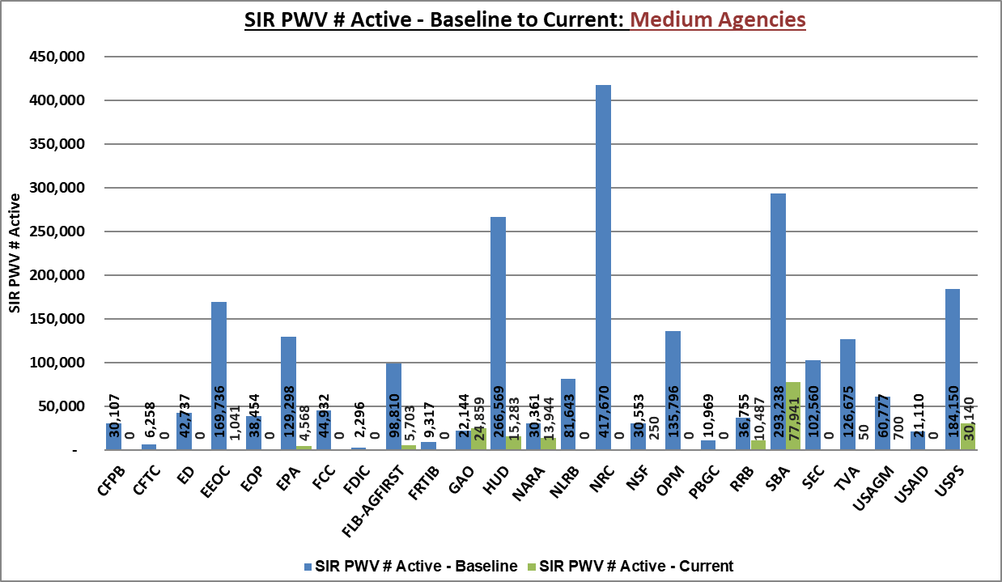

Figure 23. *SIR PWV # Active – Baseline to Current: Medium Agencies*

### 3.5.3 Transition progress - Small Agencies

Due to the large number of small agencies, the EIS Transition progress: Small Agencies table is in Appendix A.

## Transition progress – Service Category

This section identifies transition progress by service categories for SIR disconnected, SIR PWV disconnected, and BV reduction. For purposes of reporting, services have been grouped into ten (10) main categories (including taxes). A full list of services is provided in Appendix F.

Table 8 illustrates the status of transition progress by service category. The difference between the total SIR count and the number of active SIRs is divided by the total SIR count to calculate the SIR percentage disconnected; this is shown alongside the SIR PWV percentage disconnected which factors in complexity. The current BV amount ($) is compared to the initial BV amount ($) to calculate BV percentage reduction.

Table 8. *EIS Transition Progress: Service Category*

|  |  |  |  |  |  |  |  |
| --- | --- | --- | --- | --- | --- | --- | --- |
| **EIS Transition Progress: Service Category** | | | | | | | |
| **Service Category** | **Service Instance Records** | | | | **Business Volume** | | |
| **SIR # Total** | **SIR # Active** | **SIR % Disconnected** | **SIR PWV % Disconnected** | **BV $ Initial** | **BV $ Current** | **BV % Reduction** |
| **Comm Trans** | 9,191,071 | 1,638,878 | 82.2% | 86.9% | 40,726,171 | 9,565,978 | 76.5% |
| **IP Based** | 167,968 | 20,537 | 87.8% | 89.5% | 66,695,586 | 10,608,415 | 84.1% |
| **Mgt & App** | 48,237 | 7,732 | 84.0% | 84.6% | 35,754,500 | 5,793,037 | 83.8% |
| **Misc.** | 34,665 | 4,334 | 87.5% | 87.8% | 23,524,969 | 9,651,932 | 59.0% |
| **Wireless** | 5,466 | 101 | 98.2% | 98.2% | 144,409 | 6,624 | 95.4% |
| **Access** | 3,530 | 919 | 74.0% | 74.0% | 17,828,830 | 8,774,046 | 50.8% |
| **Security** | 2,364 | 34 | 98.6% | 98.6% | 550,857 | 19,776 | 96.4% |
| **Special** | 512 | 239 | 53.3% | 53.3% | 502,166 | 50,746 | 89.9% |
| **Optical** | 353 | 18 | 94.9% | 94.9% | 1,799,864 | 193,408 | 89.3% |
| **Taxes** | - | - | 0.0% | 0.0% | 11,527,836 | 5,113,162 | 55.6% |
| **TOTALS** | **9,454,166** | **1,672,792** | **82.3%** | **87.6%** | **199,055,190** | **49,777,124** | **75.0%** |

Figure 24 illustrates a current snapshot of SIR and SIR PWV percentages disconnected, BV percentage reduction, and the number of active SIRs for service categories (excluding taxes).

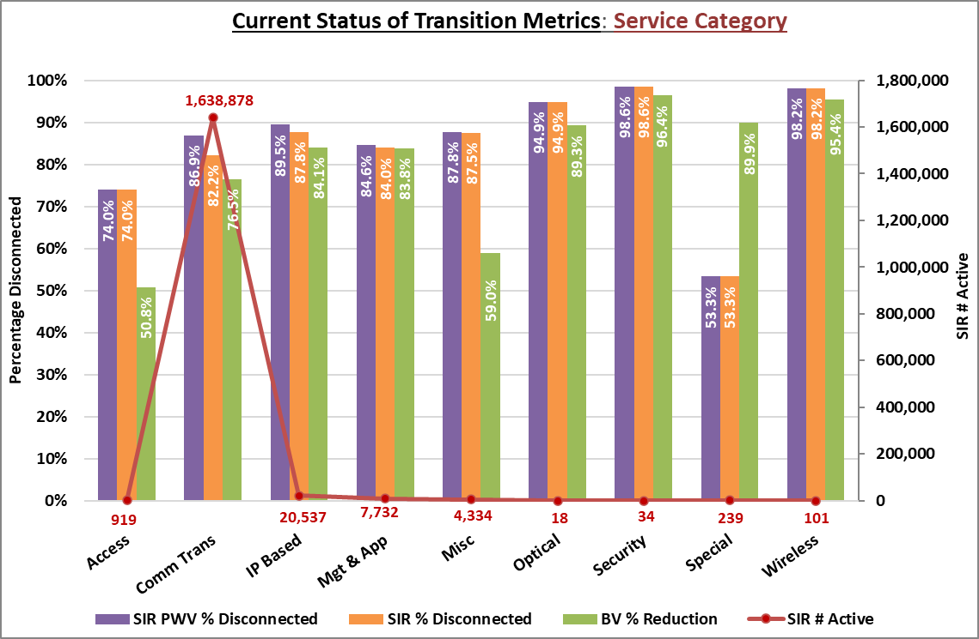

Figure 24. *Current Status of Transition Metrics: Service Category*

# Risk Management

The TCC has established a risk management program to identify, track, monitor, and control risks associated with transition, particularly as they may affect and/or be affected by the TCC. Likewise, lessons learned that present a risk to the success of agency transition to EIS before the existing contracts expire are tied to the appropriate risk and monitored in parallel.

## Lessons Learned

Lessons learned provide guidance to both current and future transition activities and assist stakeholders in minimizing impacts to service thus reducing transition delays and expenses.

## Risk Assessment

The TCC documents and assesses risks using project management best-practices.

The TCC performs a monthly risk assessment for the purposes of the TPTR using the current Risk Register. Table 9 summarizes high-level risks (defined as risks with ratings of 5 or 6), response strategies, and proposed response plans as of the current reporting period.

Table 9. *Transition Risks and Mitigation*

| **Transition Risks and Mitigation** | | | | | |
| --- | --- | --- | --- | --- | --- |
| **Risk #** | **Risk Name** | **Description of Risk** | **Rating** | **Response Strategy** | **Response Plan** |
| 20 | New U.S. Presidential Administration | New administration could result in changes in priorities, funding, and/or organization. | 5 | Escalate | • ETS Director continues to engage with OMB and CIO Councils • At-Risk Reporting  • OMB Directive for IT Modernization |
| 35 | Late disconnection of service from expiring contracts | Agencies disconnect service from expiring contracts too close to contract expiration date, causing a gap in service. | 6 | Transfer | • GSA unilaterally disconnects (transfers Risk to agency) • Agency implements an alternative acquisition as a contingency • GSA customer support engages with NWR contractors early and periodically |
| 37 | Contractors decline to extend expiring contracts | Contractors decline to propose extension of expiring contracts, or certain services on those contracts, necessitating early transition. | 5 | Share | • Monitor risk with contracting teams negotiating contract extensions • When it becomes an issue, create plan for early transition, as applicable • Send RFQ to all contractors requesting they extend; Time permitting, re-compete LSA contract for those who will not extend • For services being abandoned, negotiate latest date possible and communicate to all affected customers  • MOU for Continuity of Service period notes agency's responsibility for mitigation |
| 38 | EIS contractors may not be able to handle TOs and orders within the transition timeframe | If EIS contractors cannot handle TOs and orders within the transition timeframe, the effort is at risk of being delayed and receiving "bad press." | 6 | Mitigate | • When it becomes an issue, create plan for early transition, as applicable • Collect agency input and hold executive meetings with contractors • Agency's OCOs document performance in CPARS and take additional steps to enforce compliance • Evaluate agencies’ JOFOC prior to publication for concerns of contractor performance issues and escalate as necessary |
| 45 | Lack of oversight/enforcement on agency activity | Lack of oversight/enforcement on agency activity may result in transition delays/failure. Oversight needed by GSA senior leadership, OMB, agency senior leadership, and Congress. | 6 | Escalate | • ITC engage OMB OFPP, RMO along with CIO council and House Committee on Oversight and Reform  • Use scorecard for OMB • Engage with ATS • Extend expiring contracts • At-Risk Reporting •MOUs for continuity of service requiring signature from senior agency leadership ensure broad oversight of requirements of transition schedule • Regular interagency coordination meetings • Extend contracts to 2026 with individual agencies' justifications for "single source" |
| 47 | Internal performance issues | Contractor performance issues could cause an agency to slow or stop a transition; for example, failure to get the billing correct, slow installations, and poor service delivery. | 6 | Share | • Sharing ATP information in advance with industry may help • SLAs incorporated into EIS • Contractor QPMRs  • Agency Transition Execution spreadsheet (post award tracking of contractor performance issues) • Agency's OCOs document performance in CPARS and take additional steps to enforce contractor compliance  • Enforce Corrective Action Plan (CAP) and conduct regression testing as required |
| 50 | Lack of expertise/experience in agencies - CO | Agencies don't have sufficient resources skilled in contracts to conduct transition planning effectively. | 5 | Share | • GSA and consultants provide advice and expertise • Early engagement with OCOs • DPA training • Telecom 101 training • Leverage FOOG; Create Use Cases within FOOG • Release bulletins highlighting specific topics • At-Risk escalations • RAFT Schedule Template, RAFT Reports for agencies, and RAFT Schedule factors • Extend contracts to 2026 with individual agencies' justifications for "single source" |
| 53 | Lack of expertise/experience in agencies - ordering | OCO: Lack of skills or experience in this area or by accountable staff could result in mistakes and delays. | 5 | Transfer | • Leverage FOOG; Create scenarios within FOOG • Communication: GSA and consultants engage; Train GSA & agencies  • Address in training for agencies • MOPS Handbook • EIS Service Guides • EIS Bulletins |
| 112 | EIS awardee bids a solution it does not have | EIS awardee bids a solution it cannot implement | 5 | Transfer | • Transfer to agencies (FO evaluation criteria: Best value to allow for alternate selection, performance requirements with consequences; Share Lessons Learned) • Agencies should plan for alternative EIS contractor if first EIS contractor cannot execute |
| 139 | EIS Vendor System capabilities | EIS Vendor Systems (for example: portals, back-office business support systems, network transports, and Contract Management Systems) fail and vendor cannot provide information to GSA Systems or deliver services. | 6 | Mitigate | • Include as part of proposal submission requirements and evaluation; implement deadline (e.g. 1 yr. from notice to proceed) for contractors to meet in order to accept orders • Enforce Corrective Action Plan (CAP) and conduct regression testing as required |
| 146 | Lack of coordination with building manager for infrastructure upgrades (FS and Direct Order customers) | Agencies may not understand the technical details of the building, the POCs, or the time required for building managers to upgrade telecommunications services which may delay transition | 5 | Share | • Establish coordination within PBS • PBS and Full Service Workshops • EIS Bulletin: Volume 8 • PBS POCs on EIS webpage • Notes from interagency meeting held on 3/3/22 and disseminated slides including PBS contacts  • Notes from interagency meeting held on 10/13/22 and disseminated slides |
| 157 | Increased need for Price Analyst Support | If contractors submit substantial pricing changes during contract extension negotiations, price analyst resources will be insufficient and contracting steps will be delayed resulting in missed deadlines to execute extensions. | 5 | Accept | • Query vendors to manage expectations and look for internal resources with the necessary expertise  • Engage additional internal resources within GSA who are ready to assist with price analysis |

Appendix A – EIS Transition Progress: Small Agencies

Appendix A illustrates the EIS transition progress for small agencies by SIR % disconnected, SIR PWV % disconnected, and BV % reduction.

Appendix A illustrates the EIS transition progress for small agencies by SIR % disconnected, SIR PWV % disconnected, and BV % reduction.

Appendix A illustrates the EIS transition progress for small agencies by SIR % disconnected, SIR PWV % disconnected, and BV % reduction. Appendix A illustrates the EIS transition progress for small agencies by SIR % disconnected, SIR PWV % disconnected, and BV % reduction.Appendix A illustrates the EIS transition progress for small agencies by SIR % disconnected, SIR PWV % disconnected, and BV % reduction.

Appendix B – Transition Completion Status

| **Transition Completion Status** | | | |
| --- | --- | --- | --- |
| **Agency Category** | **AB Code** | **Agency** | **Transition Complete Date** |
| **Large Agencies** | | | |
|  |  | NONE |  |
| **Medium Agencies** | | | |
| M | 3100 | NUCLEAR REGULATORY COMMISSION | Mar 2024 |
| M | 2400 | FEDERAL RETIREMENT THRIFT INVESTMENT BOARD | Nov 2023 |
| M | 9100 | DEPARTMENT OF EDUCATION | Oct 2023 |
| M | 5000 | SECURITIES AND EXCHANGE COMMISSION | Jul 2023 |
| M | 2700 | FEDERAL COMMUNICATIONS COMMISSION | Jun 2023 |
| M | 9559 | CONSUMER FINANCIAL PROTECTION BUREAU | May 2023 |
| M | 6300 | NATIONAL LABOR RELATIONS BOARD | Feb 2023 |
| M | 1606 | PENSION BENEFIT GUARANTY CORPORATION | Feb 2023 |
| M | 9507 | COMMODITY FUTURES TRADING COMMISSION | Dec 2022 |
| M | 7200 | US AGENCY FOR INTERNATIONAL DEVELOPMENT | Mar 2022 |
| M | 1100 | EXECUTIVE OFFICE OF THE PRESIDENT | Jul 2021 |
| M | 5100 | FEDERAL DEPOSIT INSURANCE CORPORATION | May 2021 |
| **Small Agencies** | | | |
| S | 1017 | US COURT OF APPEALS FOR THE FEDERAL CIRCUIT | Mar 2024 |
| S | 9538 | DEFENSE NUCLEAR FACILITIES SAFETY BOARD | Feb 2024 |
| S | 0087 | MISCELLANEOUS NON-GOVERNMENT ACCOUNTS | Feb 2024 |
| S | 3358 | WOODROW WILSON INTERNATIONAL CENTER FOR SCHOLARS | Feb 2024 |
| S | 0005 | HOUSE OF REPRESENTATIVES | Jan 2024 |
| S | 4838 | NAVAJO AND HOPI INDIAN RELOCATION COMMISSION | Oct 2023 |
| S | AB01 | AGENCY AB | Sep 2023 |
| S | 9567 | DENALI COMMISSION | Sep 2023 |
| S | 3400 | INTERNATIONAL TRADE COMMISSION | Sep 2023 |
| S | 0019 | SENATE | Sep 2023 |
| S | 9527 | US HOLOCAUST MEMORIAL COUNCIL | Sep 2023 |
| S | 4813 | INTERAGENCY COUNCIL FOR THE HOMELESS | Aug 2023 |
| S | 1106 | INTER-AMERICAN FOUNDATION | Aug 2023 |
| S | 9522 | ARCHITECTURAL AND TRANSPORTATION BARRIERS COMPLIANCE BOARD | Jul 2023 |
| S | 9520 | COMMISSION ON FINE ARTS | Jul 2023 |
| S | 9508 | NATIONAL TRANSPORTATION SAFETY BOARD | Jul 2023 |
| S | 1831 | POSTAL REGULATORY COMMISSION | Jul 2023 |
| S | 9583 | COUNCIL OF THE INSPECTOR GENERAL ON INTEGRITY AND EFFICIENCY | Jun 2023 |
| S | 8300 | EXPORT-IMPORT BANK OF THE UNITED STATES | Jun 2023 |
| S | 9580 | FEDERAL HOUSING FINANCE AGENCY OIG | May 2023 |
| S | 5400 | FEDERAL LABOR RELATIONS AUTHORITY | May 2023 |
| S | 9563 | COURT SERVICES AND OFFENDER SUPERVISION AGENCY (DC) | Apr 2023 |
| S | 2900 | FEDERAL TRADE COMMISSION | Apr 2023 |
| S | 9502 | NATIONAL CAPITAL PLANNING COMMISSION | Apr 2023 |
| S | 7400 | AMERICAN BATTLE MONUMENTS COMMISSION | Mar 2023 |
| S | 4810 | NUCLEAR WASTE TECHNICAL REVIEW BOARD | Mar 2023 |
| S | 1113 | PEACE CORPS | Mar 2023 |
| S | 9529 | NATIONAL COUNCIL ON DISABILITY | Feb 2023 |
| S | 4951 | NATIONAL RADIO ASTRONOMY OBSERVATORY | Feb 2023 |
| S | 9524 | NATIONAL MEDIATION BOARD | Nov 2022 |
| S | 9582 | PRIVACY AND CIVIL LIBERITIES OVERSIGHT BOARD | Nov 2022 |
| S | WYAN | WYANDOTTE NATION OF OKLAHOMA (WYAN) | Oct 2022 |
| S | 5904 | INSTITUTE OF MUSEUM AND LIBRARY SERVICES | Oct 2022 |
| S | NA23 | ALASKA NATIVE TRIBAL HEALTH CO (NA23) | Sep 2022 |
| S | NC05 | SAULT STE MARIE TRIBE (NC05) | Sep 2022 |
| S | NC13 | STOCKBRIDGE-MUNSEE COMMUNITY (NC13) | Sep 2022 |
| S | 0400 | GOVERNMENT PUBLISHING OFFICE | Sep 2022 |
| S | 9300 | FEDERAL MEDIATION AND CONCILIATION SERVICE | Aug 2022 |
| S | 9000 | SELECTIVE SERVICE SYSTEM | Jun 2022 |
| S | NA59 | AUGUSTINE TRIBAL ENTERPRISE (NA59) | May 2022 |
| S | 7100 | US INTERNATIONAL DEVELOPMENT FINANCE CORPORATION | May 2022 |
| S | 9515 | ADMINISTRATIVE CONFERENCE OF THE UNITED STATES | Apr 2022 |
| S | NA40 | CONFEDERATED SALISH AND KOOTENAI (NA40) | Apr 2022 |
| S | 0300 | LIBRARY OF CONGRESS | Apr 2022 |
| S | 9577 | MILLENNIUM CHALLENGE CORPORATION | Apr 2022 |
| S | NA02 | SHOSHONE-PAIUTE TRIBE (NA02) | Mar 2022 |
| S | 6200 | US OFFICE OF SPECIAL COUNSEL | Mar 2022 |
| S | 4853 | MEDICARE PAYMENT ADVISORY COMMISSION | Feb 2022 |
| S | NC10 | PONCA TRIBE OF NEBRASKA (NC10) | Feb 2022 |
| S | NB20 | PRAIRIE BAND POTAWATOMI NATION (NB20) | Feb 2022 |
| S | NA13 | DINE COLLEGE (NA13) | Jan 2022 |
| S | 0091 | UNITED NATIONS WORLD FOOD PROGRAM | Jan 2022 |
| S | NAJE | JEMEZ PUEBLO TRIBE (NAJE) | Dec 2021 |
| S | 0915 | MEDICAID AND CHIP PAYMENT AND ACCESS COMMISSION | Dec 2021 |
| S | NA54 | WASHOE TRIBAL HEALTH (NA54) | Dec 2021 |
| S | NC09 | WINNEBAGO TRIBE OF NEBRASKA (NC09) | Dec 2021 |
| S | NA07 | ONEIDA NATION TRIBE OF INDIANS (NA07) | Oct 2021 |
| S | 0073 | ARMY AND AIR FORCE EXCHANGE SERVICE | Oct 2021 |
| S | 9512 | JAPAN - UNITED STATES FRIENDSHIP COMMISSION | Oct 2021 |
| S | 0090 | WASHINGTON METROPOLITAN AREA TRANSIT COMMISSION | Oct 2021 |
| S | NA35 | ALABAMA COUSHATTA TRIBE (NA35) | Sep 2021 |
| S | NA-B | BOIS FORTE TRIBAL RESERVATION (NA-B) | Sep 2021 |
| S | NA46 | COEUR DALENE TRIBE (NA46) | Sep 2021 |
| S | NB10 | CONFEDERATED TRIBES OF SILETZ INDIANS (NB10) | Sep 2021 |
| S | NB11 | DELAWARE NATION OF WESTERN OKLAHOMA (NB11) | Sep 2021 |
| S | NASO | SOUTH CENTRAL FOUNDATION (NASO) | Sep 2021 |
| S | 0054 | INTER-AMERICAN DEVELOPMENT BANK | Sep 2021 |
| S | 5902 | NATIONAL ENDOWMENT FOR THE ARTS | Sep 2021 |
| S | NA19 | BENEWAH MEDICAL CLINIC (NA19) | Aug 2021 |
| S | 5901 | NATIONAL ENDOWMENT FOR THE HUMANITIES | Aug 2021 |
| S | 0067 | UNITED NATIONS | Aug 2021 |
| S | NC33 | SISSETON WAHPETON COLLEGE (NC33) | Jul 2021 |
| S | NC25 | SHAKOPEE SIOUX - MYSTIC LAKE (NC25) | Jul 2021 |
| S | 0052 | FOOD AND AGRICULTURE ORGANIZATION OF THE UNITED NATIONS | Jun 2021 |
| S | 2809 | WINNEBAGO TRIBE OF NEBRASKA-HO-CHUNK INC (2809) | Jun 2021 |
| S | 2811 | WINNEBAGO TRIBE OF NEBRASKA-HO-CHUNK INC (2811) | Jun 2021 |
| S | 9511 | FEDERAL HOUSING FINANCE AGENCY | May 2021 |
| S | 9588 | GULF COAST ECOSYSTEM RESTORATION COUNCIL | May 2021 |
| S | 4892 | US CHINA SECURITY REVIEW COMMISSION | May 2021 |
| S | 1148 | US TRADE AND DEVELOPMENT AGENCY | May 2021 |
| S | NB09 | YAVAPAI-PRESCOTT TRIBE OF THE YAVAPI RESERVATION ARIZONA (NB09) | Apr 2021 |
| S | 9537 | COMMISSION FOR THE PRESERVATION OF AMERICAS HERITAGE ABROAD | Apr 2021 |
| S | 9540 | NEIGHBORWORKS AMERICA | Apr 2021 |
| S | NA48 | ZUNI TRIBE (NA48) | Mar 2021 |
| S | NA32 | COLUSA INDIAN COMMUNITY (NA32) | Feb 2021 |
| S | 1158 | MORONGO BAND OF CAHUILLA INDIANS (1158) | Feb 2021 |
| S | NATA | TANANA CHIEF TRIBE (NATA) | Feb 2021 |
| S | NA41 | CENTRAL COUNCIL TLINGIT AND HAIDA INDIAN TRIBES OF ALASKA (NA41) | Jan 2021 |
| S | NA05 | CHIEF LESCHI SCHOOLS (NA05) | Jan 2021 |
| S | NC02 | NAVAJO TRIBAL UTILITIES AUTHORITY (NC02) | Jan 2021 |
| S | 6908 | AMTRAK | Jan 2021 |
| S | 4602 | APPALACHIAN REGIONAL COMMISSION | Jan 2021 |
| S | 1294 | MILK MARKETING ASSOCIATION | Jan 2021 |
| S | 0065 | STATUE OF LIBERTY ELLIS ISLAND FOUNDATION | Jan 2021 |
| S | NB18 | HOOPA VALLEY TRIBE OF CALIFORNIA (NB18) | Dec 2020 |
| S | NB16 | RED LAKE BAND OF CHIPPEWA INDIANS (NB16) | Dec 2020 |
| S | NA29 | SQUAXIN ISLAND TRIBE (NA29) | Dec 2020 |
| S | NC21 | UTE MOUNTAIN TRIBE (NC21) | Dec 2020 |
| S | 9549 | MORRIS K UDALL AND STEWART L UDALL FOUNDATION | Dec 2020 |
| S | 9542 | OFFICE OF GOVERNMENT ETHICS | Dec 2020 |
| S | NA47 | GUIDIVILLE RANCHERIO (NA47) | Nov 2020 |
| S | NA61 | HAVASUPAI TRIBE (NA61) | Nov 2020 |
| S | NAK0 | KARUK TRIBE OF CALIFORNIA (NAK0) | Nov 2020 |
| S | NA37 | KICKAPOO TRIBE (NA37) | Nov 2020 |
| S | NA42 | NARRAGANSETT TRIBE OF RHODE ISLAND (NA42) | Nov 2020 |
| S | NC08 | ROSEBUD SIOUX TRIBE (NC08) | Nov 2020 |
| S | NA49 | SHAWNEE TRIBE (NA49) | Nov 2020 |
| S | NA44 | WHITE EAGLE HEALTH CENTER (NA44) | Nov 2020 |
| S | NA69 | WHITE MOUNTAIN APACHE TELECOM (NA69) | Nov 2020 |
| S | GRLA | GREAT LAKES INTER-TRIBAL COUNCIL (GRLA) | Oct 2020 |
| S | NA14 | PENOBSCOT INDIAN NATION (NA14) | Oct 2020 |
| S | 0084 | NATIONAL BUILDING MUSEUM | Sep 2020 |
| S | 4952 | NATIONAL CENTER FOR ATMOSPHERIC RESEARCH | Sep 2020 |
| S | NA33 | MECHOOPDA INDIAN TRIBE (NA33) | Aug 2020 |
| S | NA57 | YUROK TRIBE (NA57) | Aug 2020 |
| S | 3312 | JOHN F KENNEDY CENTER FOR THE PERFORMING ARTS | Aug 2020 |
| S | NA03 | CONFEDERATED TRIBES OF THE GRANDE RONDE COMMUNITY OF OREGON (NA03) | Feb 2020 |
| S | NAS0 | STILLAGUAMISH TRIBE (NAS0) | Feb 2020 |
| S | 0814 | CONGRESSIONAL BUDGET OFFICE | Dec 2019 |
| S | GLIF | GREAT LAKES INDIAN FISH AND WILDLIFE (GLIF) | Dec 2019 |
| S | 1917 | INTERNATIONAL BOUNDARY COMMISSION US AND CANADA | Sep 2019 |
| S | 4953 | US ARCTIC RESEARCH COMMISSION | Aug 2019 |
| S | NAS1 | STILLAGUAMISH TRIBE (NAS1) | Jun 2019 |
| S | NAS2 | STILLAGUAMISH TRIBE (NAS2) | May 2019 |
| S | 0064 | PAN AMERICAN HEALTH ORGANIZATION | Apr 2019 |
| S | 4883 | DWIGHT D EISENHOWER MEMORIAL COMMISSION | Mar 2019 |
| S | 9533 | BARRY GOLDWATER SCHOLARSHIP AND EXCELLENCE IN EDUCATION FOUNDATION | Feb 2019 |
| S | NC12 | MUCKLESHOOT INDIAN (NC12) | May 2018 |
| S | NC06 | MOHICAN NORTH STAR OPERATIONS (NC06) | May 2018 |
| S | 5600 | CENTRAL INTELLIGENCE AGENCY | Nov 2017 |
| S | 9574 | COMMISSION ON THE NATIONAL MOMENT OF REMEMBRANCE | Oct 2017 |
| S | 7618 | CHRISTOPHER COLUMBUS FELLOWSHIP FOUNDATION | Sep 2017 |
| S | 4895 | COMMISSION FOR INTERNATIONAL RELIGIOUS FREEDOM | Jul 2017 |
| S | NA56 | UNITED SOUTH AND EASTERN TRIBES (NA56) | Jun 2017 |
| S | 9551 | DIRECTOR OF NATIONAL INTELLIGENCE | Nov 2016 |
| S | 9565 | FEDERAL COORDINATOR ALASKA NATURAL GAS TRANSPORTATION PROJECTS | Nov 2016 |
| S | 1252 | GRADUATE SCHOOL USA | Nov 2016 |
| S | 9561 | RECOVERY ACCOUNTABILITY AND TRANSPARENCY BOARD | Nov 2016 |

Appendix C – Key Metrics

| **Key Metrics** | | | |
| --- | --- | --- | --- |
| **Metric** | **Target Date** | **Definition** | **Measurement** |
| Solicitations Issued to Industry | 03/31/2019 | Agencies will issue Enterprise Infrastructure Solutions (EIS) solicitations, that have passed scope review, to industry for proposals | Agency reports to General Services Administration (GSA) as solicitations are issued to industry for proposals. Solutions Brokers will collect data and make available to the Transition Coordination Center (TCC) through the solicitation forecast by the end of each month.  Note: After this target date, GSA reserves the option to cut off GSA-funded Transition Ordering Assistance (TOA) support for agencies’ solicitation development. GSA will work with agencies unable to meet this date on an individual basis. GSA will process contract modifications on Networx and Washington Interagency Telecommunications System (WITS) 3 (direct order contracts) only for mission essential services |
| Task Orders TOs) Awarded | 09/30/2019 | At least one task order awarded for each solicitation as reported by EIS contractor through the Network Hosting Center (NHC) | As EIS contractors receive TOs, they report them to GSA, and the TOs are recorded in the NHC; GSA will track that at least one TO is awarded for each solicitation the agency has forecasted  Note: After this date, GSA will cease adding services on Regional Local Service Agreement (LSA) contracts that comprise the full-service program |
| Transition 50% Complete | 03/31/2021 | Proportional Weighted Value (PWV) percentage disconnected | 50% of Transition Inventory (TI) is disconnected as reported by Networx contractors, WITS 3 Program Management Office (PMO), and Telecommunications Ordering and Pricing System (TOPS) based on Service Instance Record (SIR) PWV disconnects |
| Transition 90% Complete | 03/31/2022 | Proportional Weighted Value (PWV) percentage disconnected | 90% of TI is disconnected as reported by Networx contractors, WITS 3 PMO, and TOPS based on SIR PWV disconnects |
| Transition 100% Complete (disconnected) | 09/30/2022 | 100% of services disconnected | 100% of TI is disconnected as reported by Networx contractors, WITS 3 PMO, and TOPS based on SIR PWV disconnects |

*Note: Transition is complete after TI is 100% disconnected and BV is reduced to $0 with no remaining charges.*

Appendix D – Key Definitions

| **Key Definitions** | |
| --- | --- |
| **Term** | **Definition** |
| Baseline Service Instance Record (SIR) | The count of active SIRs in TI on November 1, 2016. |
| Baseline SIR Proportional Weighted Value (PWV) | The count of active SIRs in TI on November 1, 2016, where services were multiplied by the appropriate weighted value and resulting values were summed. |
| Business Volume (BV) | The amount billed by the contractors for services, including adjustments, taxes and fees; sometimes includes adjustments made by GSA |
| BV Reduction | A transition progress metric that compares current BV to the initial BV |
| Fair Opportunity (FO) Solicitations Expected/Planned | Count based on information agencies provided in their Agency Transition Plan (ATP) (or subsequently in a data call from Solutions Brokers). |
| FO Solicitations Issued to Industry | Count of solicitations that have been released to Enterprise Infrastructure Solutions (EIS) contractors |
| FO Solicitations Passed In-Scope Review | Count defined as passing a General Services Administration (GSA) in-scope review |
| Initial BV | The business volume as of November 1, 2016 |
| Large, Medium, Small (LMS) Agency Categories | In the context of the transition program, agencies with inventory that must be transitioned are categorized into three main categories: Large agencies, Medium agencies, and Small agencies. The Large agencies represent a group of agencies each billing an average annual BV of more than $10 million in Fiscal Year (FY)12 through FY15 on the Networx contracts. The Medium agencies represent a group of agencies each with an average annual of less than $10 million, but over $1 million. Finally, the Small agencies represent a group of agencies each with an average annual of less than $1 million. |
| Proportional Weighted Value (PWV) | Values assigned to SIRs based on the complexity of transitioning that service (simple services, such as calling cards, reflect a low PWV, while more complex services such as Network Based Internet Protocol Virtual Private Network Service (NBIPVPNS) hold a higher value) |
| Service Instance Record (SIR) | Level of inventory tracking record that provides GSA and transition entities with a consistent measure to track services as they transition from expiring contracts; Represents a summarized rollup of a base service and the associated supporting/feature CLINs, supports transition entity transition planning, and provides a mechanism for the transition entities and GSA to track the progress of transition from Networx, Washington Interagency Telecommunications System (WITS) 3, and GSA Regional Local Service (RLS) contracts |
| SIR Disconnected | A transition progress metric that measures reductions in SIR counts until there are no active SIRs remaining (100% disconnected) |
| TPTR Report Grouping Levels | * Government-wide: This grouping represents the aggregate of all government agencies collectively. * Program: The program category view reflects the three main contract groups that are expiring and must transition. These groups are: * Networx (Universal and Enterprise) * GSA RLS * WITS 3 * Agency Category: This grouping represents the levels at which agencies are grouped for reporting purposes within this report. There are three categories: Large agencies, Medium agencies, and Small agencies (See LMS key term and definition above). * Contractor: The contractor category view reflects a grouping by individual contractor. All GSA RLS contractors are grouped together as “Other.” The contractor groups are: * American Telephone & Telegraph (AT&T) * CenturyLink * Level 3 * GSA RLS * Sprint * Verizon * Service Category: This represents all services under the expiring Networx, WITS 3, and RLS contracts; and are grouped into the following ten categories of services: * Access * Communications Transport Services * Internet Protocol (IP) Based Services * Management and Application Services * Miscellaneous * Optical Services * Security Services * Special Services * Taxes * Wireless Services |
| Transition | The movement from the expiring Networx, WITS 3 and GSA RLS vehicles to the replacement EIS contracts |
| Transition Complete | Transition Complete represents each transition entity’s achievement of transition including 100% of SIRs disconnected and 100% of BV reduction with no remaining charges. |
| Transition Entity | The level at which the agencies intend to manage their organization’s transition activities is referred to as a “transition entity.”  Some agencies may manage their transition activities at the agency level, while others may manage transition at the sub agency level. Still others may separate only one or two sub agencies from the overall parent and manage their transitions accordingly.  The Transition Entities List is located on the [GSA EIS Transition webpage](https://www.gsa.gov/technology/technology-purchasing-programs/telecommunications-and-network-services/enterprise-infrastructure-solutions/enterprise-infrastructure-solutions-eis-transition). |
| Transition Inventory (TI) | A collection of inventory records at the service instance level, reflecting services that must be transitioned off the expiring Networx, WITS 3 and GSA RLS contracts; TI will be updated, at least monthly, to reflect services as they are added, changed, or disconnected from the expiring contracts. This data is available to agency customers through the Enhanced Monthly Online Records and Reports of Information Technology Services (E-MORRIS) online application. |

Appendix E – Acronyms

| **Acronyms** | |
| --- | --- |
| **Acronym** | **Definition** |
| AB | Agency Bureau |
| ATP | Agency Transition Plan |
| ATS | Agency Transition Sponsor |
| AT&T | American Telephone & Telegraph |
| BV | Business Volume |
| CAP | Corrective Action Plan |
| CFPB | Consumer Financial Protection Bureau |
| CFTC | Commodity Futures Trading Commission |
| CIO | Chief Information Officer |
| CLIN | Contract Line-Item Number |
| CO | Contracting Officer |
| CPARS | Contractor Performance Assessment Reporting System |
| DHS | US Department of Homeland Security |
| DOC | US Department of Commerce |
| DOD | US Department of Defense |
| DOE | US Department of Energy |
| DOI | US Department of the Interior |
| DOJ | US Department of Justice |
| DOL | US Department of Labor |
| DOS | US Department of State |
| DOT | US Department of Transportation |
| DPA | Delegation of Procurement Authority |
| DTID | Deliverable Tracking Identification |
| ED | US Department of Education |
| EEOC | US Equal Employment Opportunity Commission |
| EIS | Enterprise Infrastructure Solutions |
| E-MORRIS | Enhanced Monthly Online Records and Reports of Information Technology Services |
| EOP | Executive Office of the President |
| EPA | US Environmental Protection Agency |
| ETS | Enterprise Technology Solutions |
| FCC | Federal Communications Commission |
| FDIC | Federal Deposit Insurance Corporation |
| FLB | Federal Land Banks |
| FO | Fair Opportunity |
| FOOG | Fair Opportunity and Ordering Guide |
| FRTIB | Federal Retirement Thrift Investment Board |
| FS | Full Service |
| FY | Fiscal Year |
| GAO | US Government Accountability Office |
| GSA | General Services Administration |
| HHS | US Department of Health and Human Services |
| HUD | US Department of Housing and Urban Development |
| IP | Internet Protocol |
| ITC | Information Technology Category |
| ITS | Integrated Technology Services |
| JOFOC | Justification for Other than Full and Open Competition |
| LMS | Large, Medium, Small (Agency Categories) |
| LSA | Local Service Agreement |
| MOU | Memorandum of Understanding |
| NARA | US National Archives and Records Administration |
| NASA | National Aeronautics and Space Administration |
| NBIPVPNS | Network Based Internet Protocol Virtual Private Network Service |
| NHC | Network Hosting Center |
| NLRB | National Labor Relations Board |
| NRC | US Nuclear Regulatory Commission |
| NSF | National Science Foundation |
| NWR | Networx, WITS 3, Regional |
| OCO | Ordering Contracting Officer |
| OFPP | Office of Federal Procurement Policy |
| OGP | Office of Government Procurement |
| OMB | Office of Management and Budget |
| OPC | Office of the People’s Counsel |
| PBGC | Pension Benefit Guaranty Corporation |
| PBS | Public Buildings Service |
| PMO | Project Management Office |
| POC | Point of Contact |
| PWV | Proportional Weighted Value |
| QPMR | Quarterly Program Management Review |
| RAFT | Risk Assessment for Transition |
| RFQ | Request for Quotation |
| RLS | Regional Local Service |
| RMO | Resource Management Office |
| RRB | US Railroad Retirement Board |
| SBA | US Small Business Administration |
| SEC | US Securities and Exchange Commission |
| SIR | Service Instance Record |
| SLA | Service Level Agreement |
| SSA | US Social Security Administration |
| TCC | Transition Coordination Center |
| TI | Transition Inventory |
| TO | Task Order |
| TOA | Transition Ordering Assistance |
| TOPS | Telecommunications Ordering and Pricing System |
| TPTM | Transition Progress Tracking Methodology |
| TPTR | Transition Progress Tracking Report |
| TVA | Tennessee Valley Authority |
| USAGM | US Agency for Global Media |
| USAID | US Agency for International Development |
| USDA | US Department of Agriculture |
| USPS | US Postal Service |
| VA | US Department of Veterans Affairs |
| WITS | Washington Interagency Telecommunications System |

Appendix F – Service Type Standardization and Proportional Weighted Values

| **Service Type Standardization and Proportional Weighted Values** | | | | | |
| --- | --- | --- | --- | --- | --- |
| **Program** | **Category** | **Service** | **Line Service** | **Service Description** | **PWV** |
| GSA RLS | ACCESS | ACCESS | WIRELINE | WIRELINE ACCESS | 50 |
| GSA RLS | COMMUNICATIONS TRANSPORT SERVICES | ETHS |  | ETHERNET | 100 |
| GSA RLS | COMMUNICATIONS TRANSPORT SERVICES | FRS |  | FRAME RELAY SERVICE | 100 |
| GSA RLS | COMMUNICATIONS TRANSPORT SERVICES | PLS |  | PRIVATE LINE | 250 |
| GSA RLS | COMMUNICATIONS TRANSPORT SERVICES | PRI | PRI | PRIMARY RATE INTERFACE | 75 |
| GSA RLS | COMMUNICATIONS TRANSPORT SERVICES | T1 | T1 | COPPER BASED DIGITAL TRANSMISSION SYSTEM AND THE FIRST GENERATION OF TCARRIER DIGITAL SIGNAL | 50 |
| GSA RLS | COMMUNICATIONS TRANSPORT SERVICES | T1 | T1 | DEDICATED TRANSMISSION CONNECTION | 50 |
| GSA RLS | COMMUNICATIONS TRANSPORT SERVICES | TFS |  | TOLLFREE | 25 |
| GSA RLS | COMMUNICATIONS TRANSPORT SERVICES | VS | ACS | AUDIO CONFERENCING | 1 |
| GSA RLS | COMMUNICATIONS TRANSPORT SERVICES | VS | ANALOG | ANALOG LINE | 50 |
| GSA RLS | COMMUNICATIONS TRANSPORT SERVICES | VS | ANALOGBUSINESS | ANALOG BUSINESS LINE | 50 |
| GSA RLS | COMMUNICATIONS TRANSPORT SERVICES | VS | ANALOGCENTREX | ANALOG CENTREX LINE | 50 |
| GSA RLS | COMMUNICATIONS TRANSPORT SERVICES | VS | BRI | BASIC RATE INTERFACEAN ISDN | 50 |
| GSA RLS | COMMUNICATIONS TRANSPORT SERVICES | VS | BRI SPID | BASIC RATE INTERFACE SERVICE PROFILE IDENTIFIER | 0.1 |
| GSA RLS | COMMUNICATIONS TRANSPORT SERVICES | VS | DID | DIRECT INWARD DIALING | 0.1 |
| GSA RLS | COMMUNICATIONS TRANSPORT SERVICES | VS | PBX | PRIVATE BRANCH EXCHANGE LINE | 0.1 |
| GSA RLS | IP BASED SERVICES | DSL | DSL | DIGITAL SUBSCRIBER LINE | 50 |
| GSA RLS | IP BASED SERVICES | IP | VOIP | VOICE OVER IP | 50 |
| GSA RLS | IP BASED SERVICES | IP | VOIPA | VOICE OVER IP AGENCY | 50 |
| GSA RLS | IP BASED SERVICES | IP | VOIPG | VOICE OVER IP GSA | 50 |
| GSA RLS | IP BASED SERVICES | IP | VOIPTA | VOICE OVER IP TRANSPORT AGENCY | 50 |
| GSA RLS | IP BASED SERVICES | IP | VOIPTG | VOICE OVER IP TRANSPORT GSA | 50 |
| GSA RLS | IP BASED SERVICES | IP |  | INTERNET PROTOCOL | 50 |
| GSA RLS | IP BASED SERVICES | NBIPVPNS |  | NETWORKBASED IP VPN | 100 |
| GSA RLS | MISCELLANEOUS | CPE |  | CUSTOMER PREMISES EQUIPMENT | 1 |
| GSA RLS | MISCELLANEOUS | MISC | BA | BILLING ARRANGEMENT | 0.1 |
| GSA RLS | MISCELLANEOUS | MISC | DATA CIRCUIT MISCELLANEOUS | DATA CIRCUIT MISCELLANEOUS | 50 |
| GSA RLS | MISCELLANEOUS | MISC | DLS | DIGITAL LINE SERVICE | 50 |
| GSA RLS | MISCELLANEOUS | MISC | OTHER | DATA CIRCUIT WIRING | 1 |
| GSA RLS | MISCELLANEOUS | MISC | OTHER | MISCELLANEOUS OTHER | 50 |
| GSA RLS | MISCELLANEOUS | MISC | PBXSYS | PRIVATE BRANCH EXCHANGE SYSTEM | 50 |
| GSA RLS | MISCELLANEOUS | MISC | SAF | STAND ALONE FEATURE(S) | 50 |
| GSA RLS | MISCELLANEOUS | MISC | TV | SATELLITE/CABLE TELEVISION SERVICE | 50 |
| GSA RLS | OPTICAL SERVICES | DFS |  | DARK FIBER SERVICE | 100 |
| GSA RLS | OPTICAL SERVICES | SONET |  | SYNCHRONOUS OPTICAL NETWORK (SONET) | 100 |
| NETWORX | ACCESS | ACCESS | BROADBAND | BROADBAND ACCESS | 50 |
| NETWORX | ACCESS | ACCESS | DEDICATED | DEDICATED ACCESS | 50 |
| NETWORX | ACCESS | ACCESS | WIRELESS | WIRELESS ACCESS | 50 |
| NETWORX | ACCESS | ACCESS | WIRELINE | WIRELINE ACCESS | 50 |
| NETWORX | COMMUNICATIONS TRANSPORT SERVICES | ATM |  | ASYNCHRONOUS TRANSFER MODE | 100 |
| NETWORX | COMMUNICATIONS TRANSPORT SERVICES | CSDS |  | CIRCUIT SWITCHED DATA SERVICE | 1 |
| NETWORX | COMMUNICATIONS TRANSPORT SERVICES | ETHS |  | ETHERNET | 100 |
| NETWORX | COMMUNICATIONS TRANSPORT SERVICES | FRS |  | FRAME RELAY SERVICE | 100 |
| NETWORX | COMMUNICATIONS TRANSPORT SERVICES | PLS |  | PRIVATE LINE | 250 |
| NETWORX | COMMUNICATIONS TRANSPORT SERVICES | PRI | PRI | PRIMARY RATE INTERFACE | 75 |
| NETWORX | COMMUNICATIONS TRANSPORT SERVICES | T1 | T1 | DEDICATED TRANSMISSION CONNECTION | 50 |
| NETWORX | COMMUNICATIONS TRANSPORT SERVICES | TFS |  | TOLLFREE | 25 |
| NETWORX | COMMUNICATIONS TRANSPORT SERVICES | VS | ACS | AUDIO CONFERENCING | 1 |
| NETWORX | COMMUNICATIONS TRANSPORT SERVICES | VS | CALLING CARD | CALLING CARD | 0.1 |
| NETWORX | COMMUNICATIONS TRANSPORT SERVICES | VS | COMBINED | COMBINED (LOCAL AND LONG DISTANCE) | 50 |
| NETWORX | COMMUNICATIONS TRANSPORT SERVICES | VS | COMBINEDDID | COMBINED DIRECT INWARD DIALING | 0.1 |
| NETWORX | COMMUNICATIONS TRANSPORT SERVICES | VS | DEDICATED | DEDICATED VOICE SERVICE | 50 |
| NETWORX | COMMUNICATIONS TRANSPORT SERVICES | VS |  | VOICE SERVICE | 0.1 |
| NETWORX | IP BASED SERVICES | CDNS |  | CONTENT DELIVERY NETWORK | 50 |
| NETWORX | IP BASED SERVICES | IP | CONVERGED IP | CONVERGED IP | 100 |
| NETWORX | IP BASED SERVICES | IP | ECL | ECLOUD | 50 |
| NETWORX | IP BASED SERVICES | IP | IPTELS | IP TELEPHONY | 50 |
| NETWORX | IP BASED SERVICES | IP | IPVT | IP VIDEO TRANSPORT | 50 |
| NETWORX | IP BASED SERVICES | IP | LAYER 2 | LAYER 2 VPN | 100 |
| NETWORX | IP BASED SERVICES | IP | MTIPS | MANAGED TRUSTED INTERNET PROTOCOL SERVICES | 500 |
| NETWORX | IP BASED SERVICES | IP | VOIP | VOICE OVER IP | 50 |
| NETWORX | IP BASED SERVICES | IP | VOIPT | VOICE OVER IP TRANSPORT | 50 |
| NETWORX | IP BASED SERVICES | IP |  | INTERNET PROTOCOL | 50 |
| NETWORX | IP BASED SERVICES | MTIPS | MTIPS | MANAGED TRUSTED INTERNET PROTOCOL SERVICES | 500 |
| NETWORX | IP BASED SERVICES | NBIPVPNS |  | NETWORKBASED IP VPN | 100 |
| NETWORX | IP BASED SERVICES | PBIPVPNS |  | PREMISESBASED IP VPN | 100 |
| NETWORX | MANAGEMENT AND APPLICATION SERVICES | CCC |  | CALL CENTER/CUSTOMER CONTACT CENTER | 500 |
| NETWORX | MANAGEMENT AND APPLICATION SERVICES | CHS |  | COLOCATED HOSTING | 50 |
| NETWORX | MANAGEMENT AND APPLICATION SERVICES | CSDES |  | CUSTOMER SPECIFIC DESIGN AND ENGINEERING | 50 |
| NETWORX | MANAGEMENT AND APPLICATION SERVICES | DHS |  | DEDICATED HOSTING | 50 |
| NETWORX | MANAGEMENT AND APPLICATION SERVICES | MNS |  | MANAGED NETWORK | 50 |
| NETWORX | MANAGEMENT AND APPLICATION SERVICES | SS |  | STORAGE SERVICES | 50 |
| NETWORX | MANAGEMENT AND APPLICATION SERVICES | VTS |  | VIDEO TELECONFERENCING SERVICE | 50 |
| NETWORX | MANAGEMENT AND APPLICATION SERVICES | WCS |  | WEB CONFERENCING | 2 |
| NETWORX | MISCELLANEOUS | CPE |  | CUSTOMER PREMISES EQUIPMENT | 1 |
| NETWORX | MISCELLANEOUS | MISC | GVS | GVS MONTHLY RECURRING CHARGE | 0.1 |
| NETWORX | MISCELLANEOUS | MISC | OTHER | MISCELLANEOUS OTHER | 50 |
| NETWORX | MISCELLANEOUS | MISC |  | MISCELLANEOUS | 50 |
| NETWORX | MISCELLANEOUS | VS |  | GVS MONTHLY RECURRING CHARGE | 0.1 |
| NETWORX | OPTICAL SERVICES | DFS |  | DARK FIBER SERVICE | 100 |
| NETWORX | OPTICAL SERVICES | OWS |  | OPTICAL WAVELENGTH | 100 |
| NETWORX | OPTICAL SERVICES | SONET |  | SYNCHRONOUS OPTICAL NETWORK (SONET) | 100 |
| NETWORX | SECURITY SERVICES | AVMS |  | ANTIVIRUS MANAGEMENT | 100 |
| NETWORX | SECURITY SERVICES | IDPS |  | INTRUSION DETECTION AND PREVENTION | 100 |
| NETWORX | SECURITY SERVICES | INRS |  | INCIDENT RESPONSE | 100 |
| NETWORX | SECURITY SERVICES | MEAS |  | MANAGED EAUTHENTICATION | 100 |
| NETWORX | SECURITY SERVICES | MFS |  | MANAGED FIREWALL | 100 |
| NETWORX | SECURITY SERVICES | SMEMS |  | SECURE MANAGED EMAIL | 100 |
| NETWORX | SECURITY SERVICES | VSS |  | VULNERABILITY SCANNING | 100 |
| NETWORX | SPECIAL SERVICES | FSS |  | FIXED SATELLITE | 100 |
| NETWORX | SPECIAL SERVICES | LMR |  | LAND MOBILE RADIO | 100 |
| NETWORX | SPECIAL SERVICES | MSS |  | MOBILE SATELLITE | 100 |
| NETWORX | WIRELESS SERVICES | CDPD |  | CELLULAR DIGITAL PACKET DATA | 2 |
| NETWORX | WIRELESS SERVICES | CPCS |  | CELLULAR/PCS | 2 |
| NETWORX | WIRELESS SERVICES | MWLANS |  | MULTIMODE/WIRELESS | 2 |
| WITS 3 | ACCESS | ACCESS | INTERNET | INTERNET | 50 |
| WITS 3 | ACCESS | ACCESS | INTERNET | INTERNET ACCESS | 50 |
| WITS 3 | COMMUNICATIONS TRANSPORT SERVICES | ATM |  | ASYNCHRONOUS TRANSFER MODE | 100 |
| WITS 3 | COMMUNICATIONS TRANSPORT SERVICES | CSDS |  | CIRCUIT SWITCHED DATA SERVICE | 1 |
| WITS 3 | COMMUNICATIONS TRANSPORT SERVICES | DTS |  | DEDICATED TRANSMISSION SERVICE | 75 |
| WITS 3 | COMMUNICATIONS TRANSPORT SERVICES | FRS |  | FRAME RELAY SERVICE | 100 |
| WITS 3 | COMMUNICATIONS TRANSPORT SERVICES | GES |  | GIGABIT ETHERNET SERVICE | 100 |
| WITS 3 | COMMUNICATIONS TRANSPORT SERVICES | PRI | PRI | PRIMARY RATE INTERFACE | 75 |
| WITS 3 | COMMUNICATIONS TRANSPORT SERVICES | VS | ACS | AUDIO CONFERENCING | 1 |
| WITS 3 | COMMUNICATIONS TRANSPORT SERVICES | VS | ANALOG | ANALOG LINE | 50 |
| WITS 3 | COMMUNICATIONS TRANSPORT SERVICES | VS | BRI | BASIC RATE INTERFACEAN ISDN | 50 |
| WITS 3 | COMMUNICATIONS TRANSPORT SERVICES | VS | DID | DIRECT INWARD DIALING | 0.1 |
| WITS 3 | COMMUNICATIONS TRANSPORT SERVICES | VS | PBX | PRIVATE BRANCH EXCHANGE LINE | 0.1 |
| WITS 3 | COMMUNICATIONS TRANSPORT SERVICES | VS |  | VOICE SERVICE | 0.1 |
| WITS 3 | IP BASED SERVICES | DSL | DSL | DIGITAL SUBSCRIBER LINE | 50 |
| WITS 3 | IP BASED SERVICES | IP | VOIP | VOICE OVER IP | 50 |
| WITS 3 | IP BASED SERVICES | IP | VOIPT | VOICE OVER IP TRANSPORT | 50 |
| WITS 3 | IP BASED SERVICES | VTP |  | VIDEO TRANSPORT SERVICE | 50 |
| WITS 3 | MANAGEMENT AND APPLICATION SERVICES | CLS |  | CLOUD COMPUTING SERVICE | 100 |
| WITS 3 | MANAGEMENT AND APPLICATION SERVICES | WCS |  | WEB CONFERENCING | 2 |
| WITS 3 | MISCELLANEOUS | CPE |  | CUSTOMER PREMISES EQUIPMENT | 1 |
| WITS 3 | MISCELLANEOUS | IW |  | INSIDE WIRING | 50 |
| WITS 3 | MISCELLANEOUS | MISC | OTHER | MISCELLANEOUS OTHER | 50 |
| WITS 3 | MISCELLANEOUS | MISC | OTHER | OTHER | 50 |
| WITS 3 | MISCELLANEOUS | MISC | OTHER | OTHER DIRECT COSTS | 1 |
| WITS 3 | MISCELLANEOUS | MISC | SAF | STAND ALONE FEATURE(S) | 50 |
| WITS 3 | MISCELLANEOUS | NSEP |  | NATIONAL SECURITY AND EMERGENCY PREPAREDNESS | 1 |
| WITS 3 | OPTICAL SERVICES | DFS |  | DARK FIBER SERVICE | 100 |